Apprenticeship Portfolio

  - Apprentice: Fearghal Kavanagh
  - Training provider: Founders and Coders
  - Workplace: Turn2us
  - May 2024 – May 2025

Contents
1. Mapping 6
2. Introduction 8
2.1. Turn2us 8
2.2. My Role and the Digital Team 8
2.3. EDIB and Safeguarding 9
2.4. Tech Stack 9
2.5. Benefits Calculator (BC) Tool 9
2.6. Turn2us Personal Independence Payment (PIP) Helper Tool 9
2.7. Developer Workflow 10
2.8. Contrasting Workflows: 10
3. Benefits Calculator (BC) Retail Trust White Labelling 11
3.1. Overview 11
3.1.1. Stakeholders 11
3.2. Skills Matrix 11
3.3. Behaviour Matrix 12
3.4. Planning 12
3.4.1. Jira Sprint 12
3.4.2. Initial Codebase Analysis 13
3.4.3. GitHub 14
3.4.4. Using Browser Developer Tools 14
3.4.5. CSS Variables 15
3.4.6. Retail Trust Design Guide 15
3.4.7. User Stories 17
3.4.8. Policies and Accessibility Standards 17
3.5. Task Implementation 18
3.5.1. Initiation 19
3.5.2. Reusable CSS Variables 19
3.5.3. Issue with Border 21
3.5.4. Issue with Download Bar of Previous White Labelling 23
3.5.5. Daily Stand Ups, Testing and Deployment 23
3.5.6. Deployment conflict in UAT 24
3.5.7. Accessibility Issue with Small Screen Menu Navigation 24
3.5.8. Lighthouse Accessibility Testing 26
3.6. Results: 26
3.6.1. CSS Variables 26
3.6.2. Presenting My Work 26
3.6.3. Retail Trust 27
3.7. Knowledge matrix 28
4. PIP helper tool and the Accessibility Menu 28
4.1. Overview 28
4.1.1. Stakeholders 29
4.2. Skills matrix 29
4.3. Behaviour Matrix 29
4.4. Planning 30
4.4.1. PIP Team Planning Meeting 30
4.4.2. Examples 31
4.4.3. Frontend code architecture 32
4.5. Task Implementation 32
4.5.1. Set Up 32
4.5.2. React Components 32
4.5.3. Iterations of the Menu 34
4.5.4. Theme CSS 35
4.5.5. Issue Keyboard Focus 36
4.5.6. Head of Digital and the UX/UI Designer 36
4.5.7. Branding team 37
4.5.8. Issue with Screen Reader 37
4.6. Results 39
4.6.1. Audit Retest Meeting 39
4.6.2. Live Users 39
4.6.3. Branding 39
4.6.4. Head Of Digital and the Lightning Talk 40
4.7. Knowledge matrix 40
5. BC War pensions 41
5.1. Overview 41
6.1.1. Stakeholders 41
5.2. Skills matrix 41
5.3. Behaviour Matrix 41
5.4. Planning 41
5.4.1. Initial 42
5.4.2. Documentation 42
5.4.3. Benefit Specialist User Stories 43
5.5. Task Implementation 43
5.5.1. Sheet changes 43
5.5.2. Sheet upload 44
5.6. Results 48
5.6.1. BC Pages and Questions 48
5.6.2. Benefits Specialist User Stories 50
5.7. Knowledge matrix 50
6. PIP React testing (Testing code at Turn2Us) 51
6.1. Overview 51
6.1.1. Stakeholders 51
6.2. Skills matrix 51
6.3. Behaviour Matrix 51
6.4. Planning 51
6.4.1. What to Test 52
6.4.2. Identifying Suitable Code to Test 52
6.5. Task Implementation 52
6.5.1. Issue with Dependencies 52
6.5.2. Jest Unit Tests 52
6.5.3. End to end tests: 55
6.6. Results 57
6.6.1. Jest tests 57
6.6.2. Demo 58
6.7. Knowledge matrix 58
7. Portal test website 59
7.1. Overview 59
7.1.1. Stakeholders 59
7.2. Skills matrix 59
7.3. Behaviour Matrix 59
7.4. Planning 60
7.5. Task Implementation 60
7.5.1. Set Up 61
7.5.2. Documentation Testing 61
7.5.3. Portal Testing Site Potential 62
7.6. Results 63
7.6.1. PIP Portal Corporate Partners Documentation 63
7.6.2. Further Use 64
7.6.3. Incorporation to Turn2us Tools 64
7.6.4. Deployment checking 64
7.7. Knowledge matrix 65
8. Professional Development 65
8.1. Training 65
8.2. CS50X 65
8.3. Mentoring 65
8.4. Coding Meetups 66

Mapping
 | Definition | Evidence
 | Knowledge
K1 | All stages of the software development lifecycle (what each stage contains, including the inputs and outputs). | 2.7  3.4-3.6
K3 | The roles and responsibilities of the project lifecycle within your organisation, and your role. | 2.2, 2.7
K4 | How best to communicate using the different communication methods and how to adapt appropriately to different audiences. | 2.2  3.5.5, 3.6.2  4.6.4
K5 | the similarities and differences between different software development methodologies, such as agile and waterfall. | 2.7, 2.8
K7 | Software design approaches and patterns, to identify reusable solutions to commonly occurring problems. | 3.4.5, 3.5.1-3.5.2  4.5.5  7.6.2
K8 | Organisational policies and procedures relating to the tasks being undertaken, and when to follow them. For example, the storage and treatment of GDPR sensitive data. | 2.3  3.4.1, 3.4.3, 3.4.8
K10 | Principles and uses of relational and non-relational databases. | 5.5
K12 | Software testing frameworks and methodologies. | 3.5.8  6.5.2-6.5.3
 | Definition | Evidence
 | Skills
S2 | Develop effective user interfaces | 3.5.1-3.5.2  4.5.3  7.5.3
S3 | Link code to data sets | 5.5
S5 | Conduct a range of test types, such as integration, system, user acceptance, non-functional, performance and security testing. | 6.5.2-6.5.3
S8 | Create simple software designs to effectively communicate understanding of the program. | 3.6.2  4.5.2
S9 | Create analysis artefacts, such as use cases and/or user stories. | 3.4.7
S13 | Follow testing frameworks and methodologies. | 6.5.2-6.5.3
S14 | Follow company, team or client approaches to continuous integration, version and source control. | 2.4  2.7  3.4.3
S15 | Communicate software solutions and ideas to technical and non-technical stakeholders. | 2.2  3.5.5, 3.6.2  4.6.4
S17 | Interpret and implement a given design whist remaining compliant with security and maintainability requirements. | 3.5.2  4.5.6  5.4.2
 | Definition | Evidence
 | Behaviours
B1 | Works independently and takes responsibility. For example, has a disciplined and responsible approach to risk and stays motivated and committed when facing challenges. | 3.4.5, 3.5.4  4.5.2
B4 | Works collaboratively with a wide range of people in different roles, internally and externally, with a positive attitude to inclusion & diversity. | 2.2-2.3  4.5.6
B5 | Acts with integrity with respect to ethical, legal and regulatory ensuring the protection of personal data, safety and security. | 2.3  3.4.6-3.4.7, 3.4.8
B6 | Shows initiative and takes responsibility for solving problems within their own remit, being resourceful when faced with a problem to solve. | 3.4.5 , 3.5.3  4.5.5  7.5.3
B7 | Communicates effectively in a variety of situations to both a technical and non-technical audience. | 2.2, 2.7  3.5.5, 3.6.2  4.6.4
B8 | Shows curiosity to the business context in which the solution will be used, displaying an inquisitive approach to solving the problem. This includes the curiosity to explore new opportunities, techniques and the tenacity to improve methods and maximise performance of the solution and creativity in their approach to solutions. | 3.4.5-3.4.6  4.5.5-4.5.6  7.6.4
B9 | Committed to continued professional development. | 2.3  8

Introduction

Turn2us
Turn2us is a national charity that provides practical help to people who are struggling financially. There are approximately 120 employees, spread across many different departments with varied roles and there are a variety of digital and non-digital projects happening. I work as part of the in-house digital team. We develop multiple digital products to achieve the charity’s objective. We also work with external partners who pay for our digital tools to help their members which also increases our reach.

My Role and the Digital Team
In my role in the digital team, I am assigned to work on tickets, report back in daily stand ups and planning meetings, I develop locally and deploy to environments such as staging and User Acceptance Testing (UAT) as needed. The digital team is comprised of a head of digital, 5 developers, 3 project managers, a product owner, and a UX/UI designer. The two main projects that I work on, are the benefits calculator (BC) and the Turn2us PIP (Personal Independence Payment) helper tool. Both have teams that also include benefits specialists as the product owners due to the nature of the tools. These benefit specialists are from the Information Programs team. Since we work closely with non-developers, we avoid technical jargon and focus on clear, easy-to-understand communication.

EDIB and Safeguarding
There is a strong importance placed on Equality, Diversity, Inclusion & Belonging (EDIB) and safeguarding in Turn2us which as a culture is extremely refreshing. This is included in our ways of working, training, considered when dealing with members of the public or co-production partners and when developing any work as part of our software development lifecycle. In the initial set up our projects need to have an EDIB checklist, a safeguarding risk assessment and a project risk assessment using Risk, Assumptions, Issues and Dependencies (RAID) log.
Turn2us supports employees to set up internal support groups and during my induction, I was given the opportunity to join any that I felt I would be suitable for. I joined the LGBTQIA+ safe space, which meets monthly to discuss any issues and act as a social group with semi regular events.

Tech Stack
At Turn2us the tech stack consists of JavaScript and React for the frontend. For the Backend we use C#, .NET and SQL. We use Git for version control and host our repositories on GitHub. For deployment we have a server at an external company which we can remote desktop into to deploy manually.

Benefits Calculator (BC) Tool
Our BC is long established and now one of the things Turn2us is most known for. The success of this tool led to the charity rebranding to use what was then the digital arm of the charity’s branding as the main branding with the public. The BC has used many different technologies over the years, and its most recent instance was developed over the past 3-4 years. There are constant changes to the calculator as UK benefits are complex and ever changing. The corporate partnerships team say it helps to open doors as people know it and then they can talk about our wider suite of tools.

Turn2us Personal Independence Payment (PIP) Helper Tool
The PIP helper tool is the newest tool and was launched just before I joined Turn2us. It was created with accessibility in mind from its inception, as it is a tool to help people apply for a disability benefit. Being added to the project post launch was an interesting time as it allowed me to see the agile workflow in process. There was accessibility testing, pen testing, bug fixing and development of new features.

  - Developer Workflow
In my role as a developer on the BC and PIP helper I worked in an agile workflow. Our agile workflow focuses on having small manageable sprints, with a focus on continuous feedback, flexibility, and collaboration. We have multiple standups a week, and work to two- or three-week sprints which are decided in a planning meeting. We use a kanban board (Jira) to track our work and potential work (backlog). In our planning meetings we pick tickets for the sprint by assessing the backlog. For larger pieces of work, focus can be set by using epics, when the work is expected to span many sprints. Otherwise, we deliver small, incremental changes in each sprint.
Turn2us’ agile workflow results in our work being efficient as it is iterative and incremental. On our Jira board (Figure 1) we have columns to track the progress of a ticket, which are: To Do, Doing/In Progress, Ready For Testing, Testing, Passed Test, For Deployment and Done. These align with the software development life cycle of plan, design, implement, test, deploy, maintain. Plan, design and implement are covered by adding to the backlog, moving to To Do and Doing/In Progress. Testing is covered by Ready For Testing, Testing and Passed Test. Deployment is covered by for deployment. Maintain is our business as usual and this is a constant in our work, feedback and bug fixes are fed into the backlog and sprints as needed.

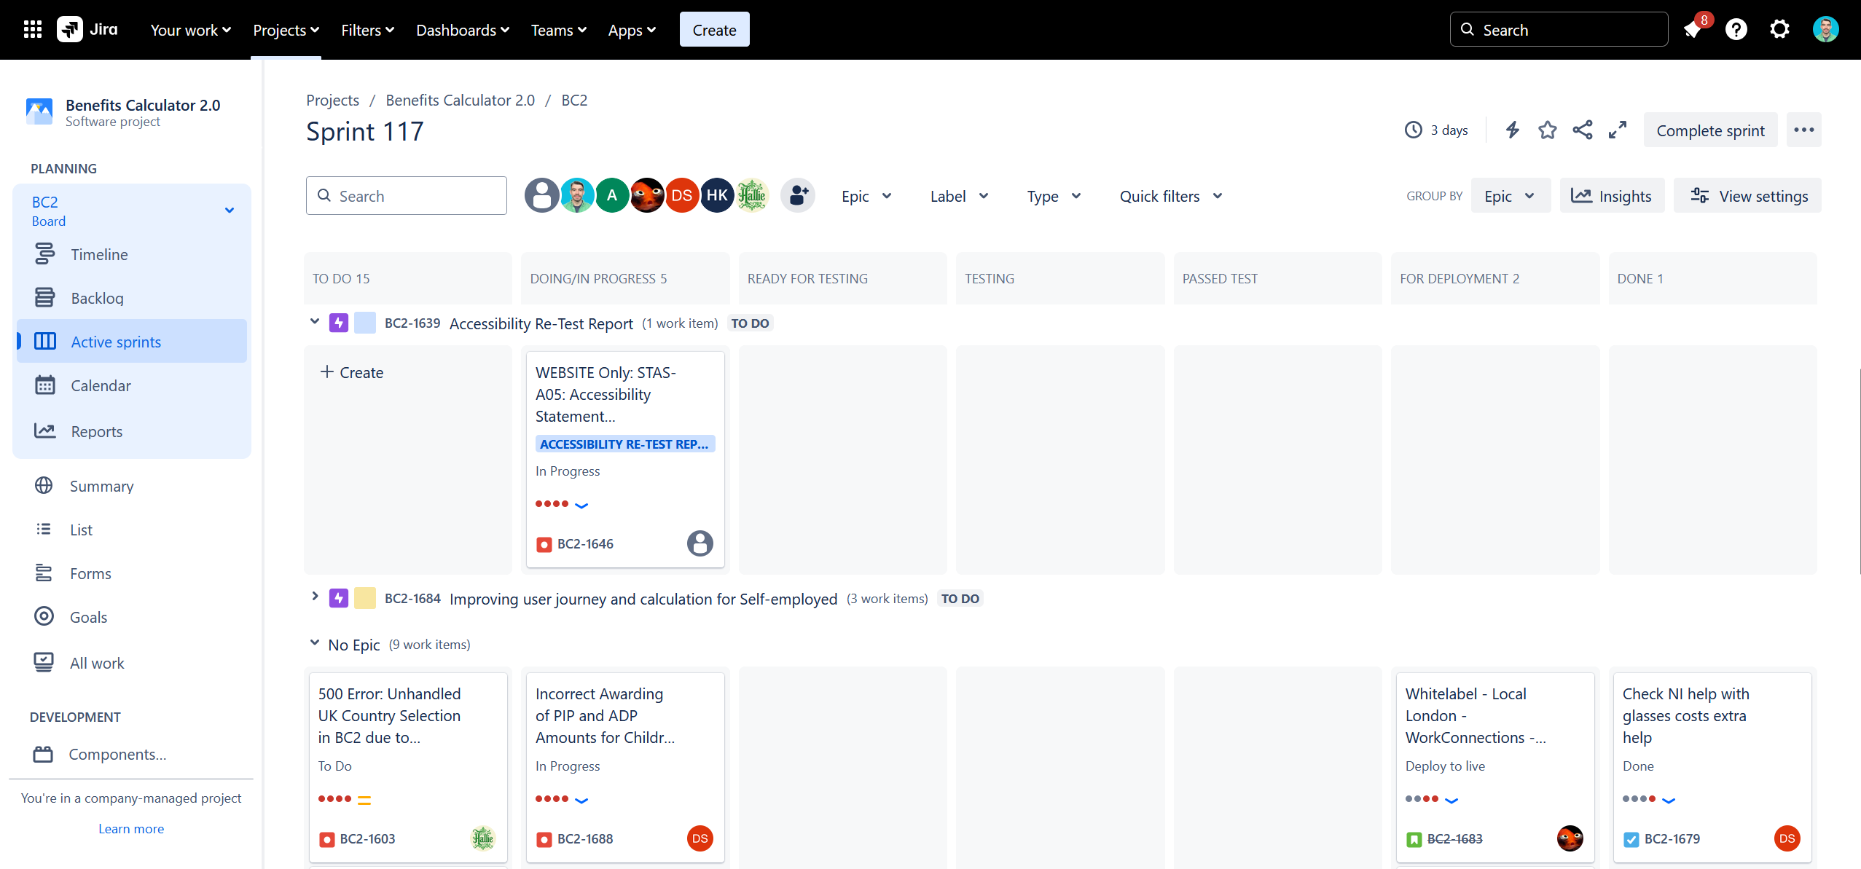
Figure 1: Our Jira board showing the columns and an epic (Accessibility Re-Test Report) and No Epic tickets

Contrasting Workflows
This agile workflow contrasts with waterfall and iterative. Waterfall has sequential phases; each new phase depends on the last. There are tangible outcomes after each phase but there is not as much room for change, and this can affect delivery in a larger project. Iterative starts small and builds usable software at each development cycle.

Benefits Calculator (BC) Retail Trust White Labelling

Overview
The Retail Trust had signed a deal to white label our BC. This was deemed a priority to start this work immediately as it had a deadline of 6 weeks. The task involved taking our BC tool and applying the design guide of the retail trust to white label it as theirs. Turn2us has accessibility standards for our tools, so these had to be maintained as part of any white labelling work. My manager told me a similar white labelling had been carried out before and that I should start by looking at these files. To showcase my work, I would present the completed task to my manager and the head of digital (his manager). The retail trust would liaise with our head of digital and once complete it would be hosted on their website.

Stakeholders
BC team - responsible for development and implementation
Head of digital - project oversight and liaison with external partner
Retail Trust - client and end user of the white-labelled calculator

Skills Matrix

ID | Skills | Section
S2 | Develop effective user interfaces. | 3.5.1-3.5.2
S8 | Create simple software designs to effectively communicate understanding of the program. | 3.6.2
S9 | Create analysis artefacts, such as use cases and/or user stories. | 3.4.7
S14 | Follow company, team or client approaches to continuous integration, version and source control. | 3.4.3
S15 | Communicate software solutions and ideas to technical and non-technical stakeholders. | 3.5.5,  3.6.2
S17 | Interpret and implement a given design whilst remaining compliant with security and maintainability requirements. | 3.5.2

Behaviour Matrix
ID | Behaviours | Section
B1 | Works independently and takes responsibility. For example, has a disciplined and responsible approach to risk and stays motivated and committed when facing challenges. | 3.4.5  3.5.4
B5 | Acts with integrity with respect to ethical, legal and regulatory ensuring the protection of personal data, safety and security. | 3.4.8
B6 | Shows initiative and takes responsibility for solving problems within their own remit, being resourceful when faced with a problem to solve. | 3.4.5  3.5.3
B7 | Communicates effectively in a variety of situations to both a technical and non-technical audience. | 3.5.5  3.6.2
B8 | Shows curiosity to the business context in which the solution will be used, displaying an inquisitive approach to solving the problem. This includes the curiosity to explore new opportunities, techniques and the tenacity to improve methods and maximise the performance of the solution and creativity in their approach to solutions. | 3.4.5-3.4.6

Planning

Jira Sprint
As this work had a deadline with an external partner, the product manager moved it into the current sprint in Jira. I would be responsible for this work, so I was assigned this ticket during the daily stand up (Figure 2). The Jira ticket was moved from the to do column to the in-progress column. This workflow gives visibility to the team, so you can tell who is currently working on a ticket and at what stage the work is at. The product manager runs the planning meetings; daily stand ups and maintains Jira.

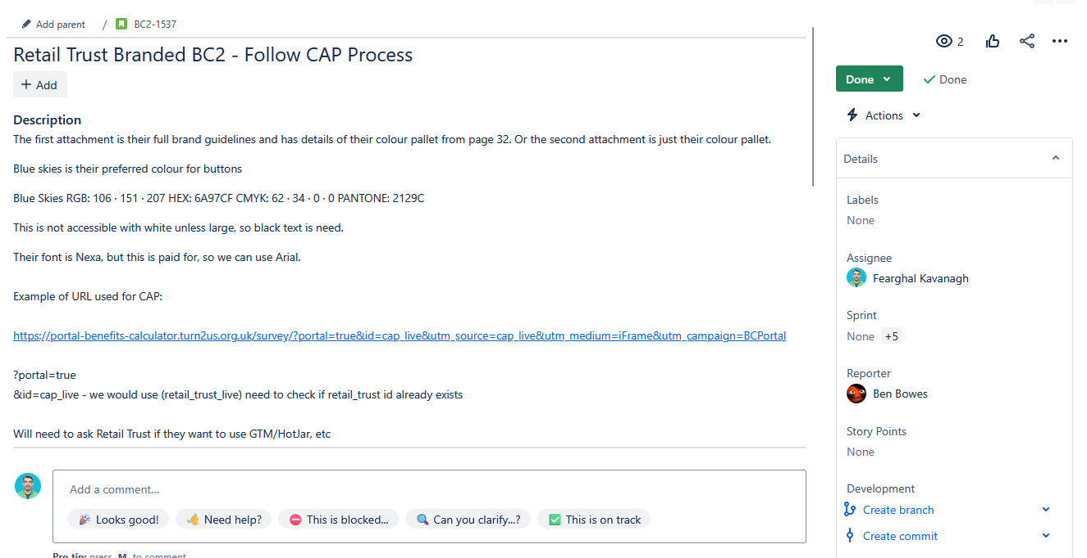
Figure 2: Ticket on Jira which I was assigned

Initial Codebase Analysis
I evaluated whether implementing the white labelling would require frontend or backend change as we have separate GitHub repos for both. As it was a CSS (Cascading Style Sheets) change I started by looking at the frontend. I found the files for the previous white labelling done for Christians Against Poverty (CAP) in the folder structure and reviewed them (Figure 3). The files were well laid out and there was separation of concern as the previous white labelling had its own files and separate JavaScript files to apply the CSS files.

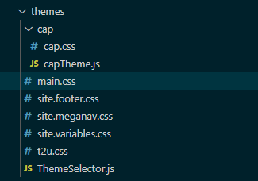
Figure 3: Repo file structure for CSS

GitHub
I ensured my GitHub repo was up to date with the remote and that I was on the main branch. I planned to make a separate GitHub branch from the main branch to save and track my work as small commits. There was an active branch called accessibility that was being used for accessibility fixes, and I was instructed to save my changes to this branch instead of creating a new branch. I planned to use conventional commits to promote readability and understandability for myself and other developers. I did this by structuring my commit with a keyword at the beginning. (Figure 4)

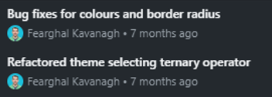
Figure 4: Conventional git commits

Using Browser Developer Tools
I needed to familiarise myself with the existing code base and since I was working with JavaScript and React, I thought to use the Firefox Web Developer Tools, I could inspect the elements to quickly understand the front end before making any changes (Figure 5). I worked my way through the BC checking the elements and which CSS was applied to them.

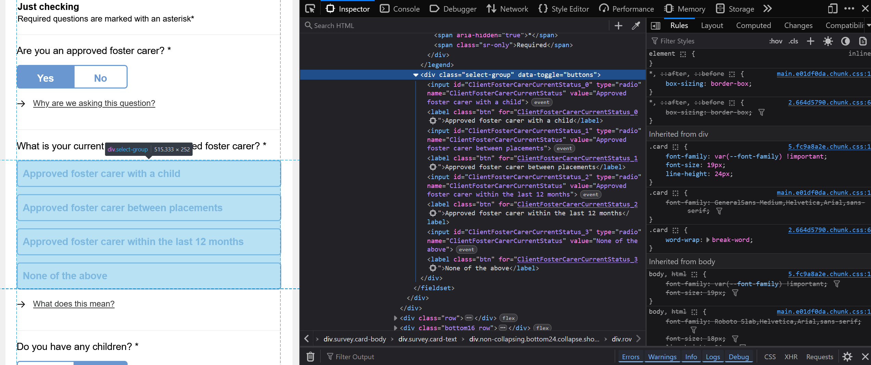
Figure 5: Using inspect I could see the html and CSS of the frontend elements.

CSS Variables
I researched using CSS variables to help make it easier to switch between the different CSS themes that would be applied. We use bootstrap so I researched if we could make a bootstrap theme for our site and then a theme for any white labelling we needed. This seemed to be quite a complicated task, so I did further research and came across the idea of using CSS variables instead. I found two main CSS variable options, CSS and SCSS (Sassy CSS). A benefit of SCSS is that it is dynamic and then compiled into CSS which can help catch errors. As CSS variables would require less changes to our existing code base I decided to use this method. I used reference websites that I trusted to research such as developer.mozilla.org and www.w3schools.com.

Retail Trust Design Guide
When researching the colours the retail trust use, I was concerned about the use of white text on a light blue background for their buttons. I discovered in their style guide (Figure 6-7) they had documented this and recommended to use font over 18px for all non-foundation stone coloured text (Figure 7). Text displayed in this way allowed it to be considered large text (Figure 8) and to pass Web Content Accessibility Guidelines (WCAG) level AA.
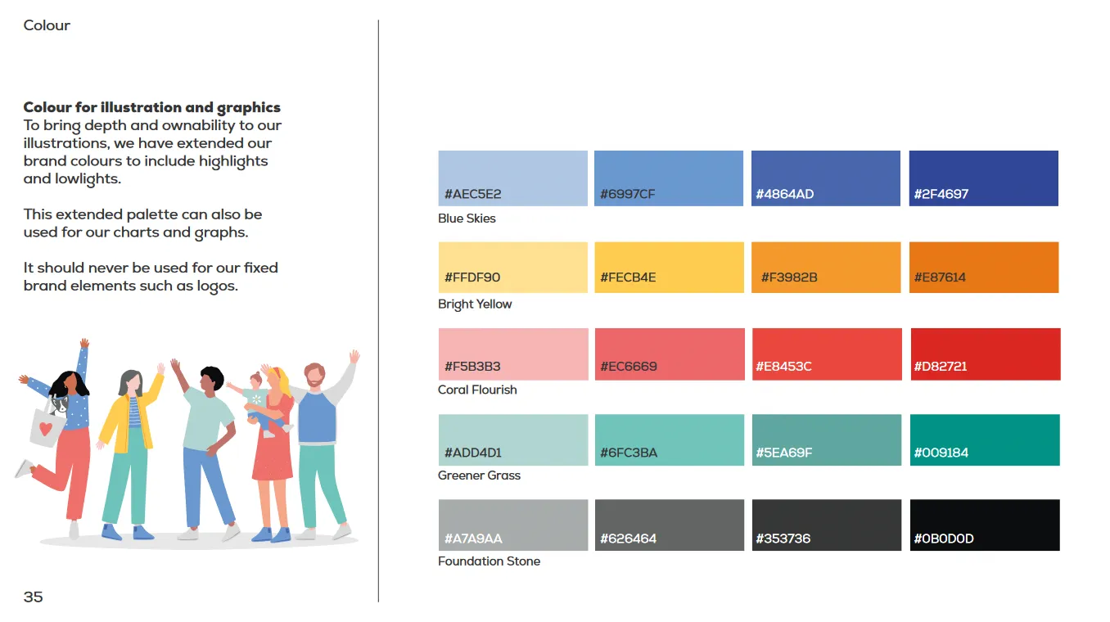
Figure 6: Retail Trust brand guide colours page

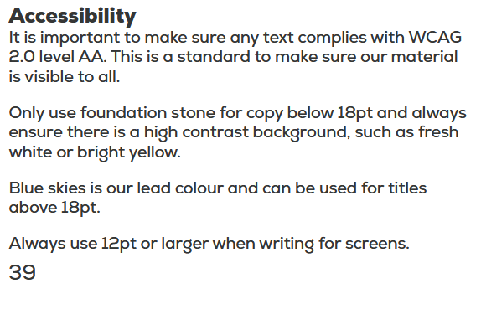
Figure 7: Retail Trust need white on blue buttons to be over 18px

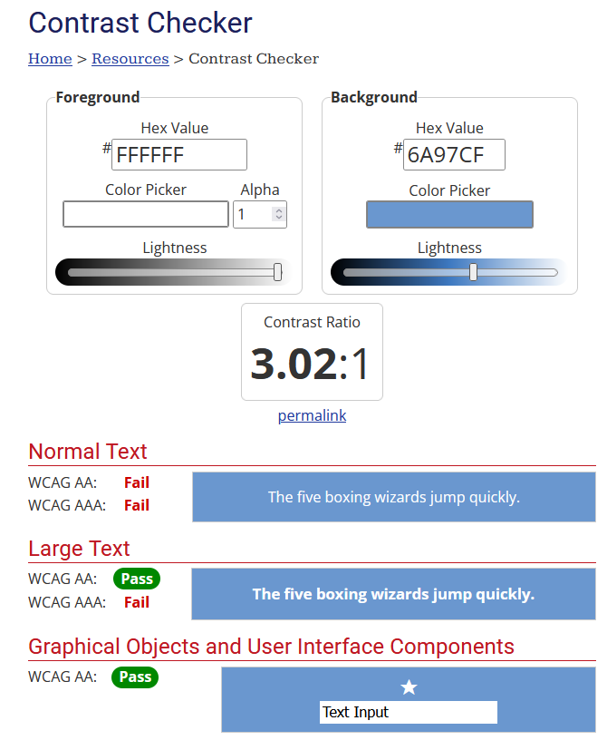
Figure 8: Contrast checking of Retail Trusts light blue and white test. Note the pass on large text for WCAG AA

User Stories
I developed two primary user stories to guide my approach:
- Retail Trust website users should experience a seamless transition between the main site and our hosted BC, maintaining consistent branding and design language throughout.
- All Retail Trust users, including those with accessibility requirements should be able to navigate the BC easily. It should support keyboard navigation and screen reader compatibility, while maintaining WCAG level AA colour contrast ratios.

Policies and Accessibility Standards
Our internal documentation on Teams provides clear guidelines on ensuring our digital tools are accessible, with training delivered to all staff to foster awareness. This training took place before I joined Turn2us, but I was able to review the materials on Teams to familiarise myself with the standards (Figure 9). We adhere to the WCAG level AA for our BC, which has been audited to ensure compliance.
The tool is designed with General Data Protection Regulation (GDPR) principals in mind, collecting only essential user data. While certain details such as date of birth and postcode are necessary for calculations, users are not required to provide their name or gender. They have the option to use the tool anonymously with a reference code supplied to them which allows them to return to the same calculation, or they can make an account to save their progress.
As a part of our data protection, all staff receive training in GDPR during induction, followed by annual refresher sessions. This is further supported by online training modules hosted on Boxphish, ensuring our knowledge remains up to date. (Figure 10-11)

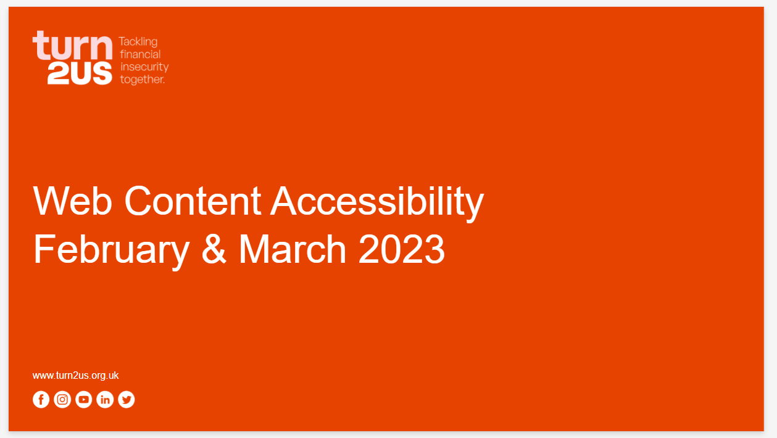
Figure 9: All staff presentation on Web Content Accessibility

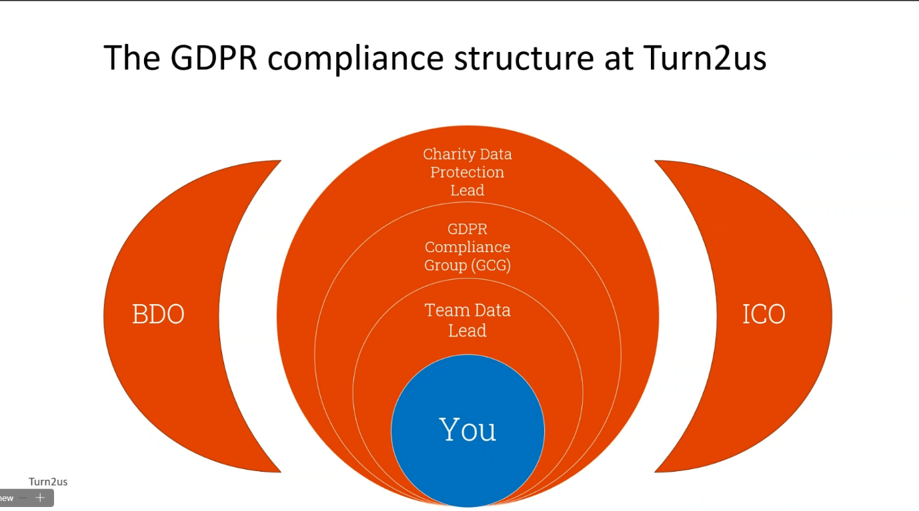
Figure 10: A slide from the GDPR talk given to all staff
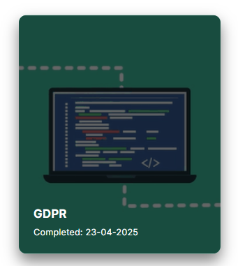
Figure 11: My completed GDPR module on Boxphish

Task Implementation

Initiation
To implement this task, I followed Turn2us’s code conventions and set up the files as it had been previously done for CAP. I incorporated basic styling and configured it in my local development environment, allowing me to view the digital tool with my styles attached. I created all the CSS variables for colours, font style and border radius, adding these to the top of the retailTrust.css file (Figure 12). This approach allowed me to consistently apply these styling elements throughout the project.
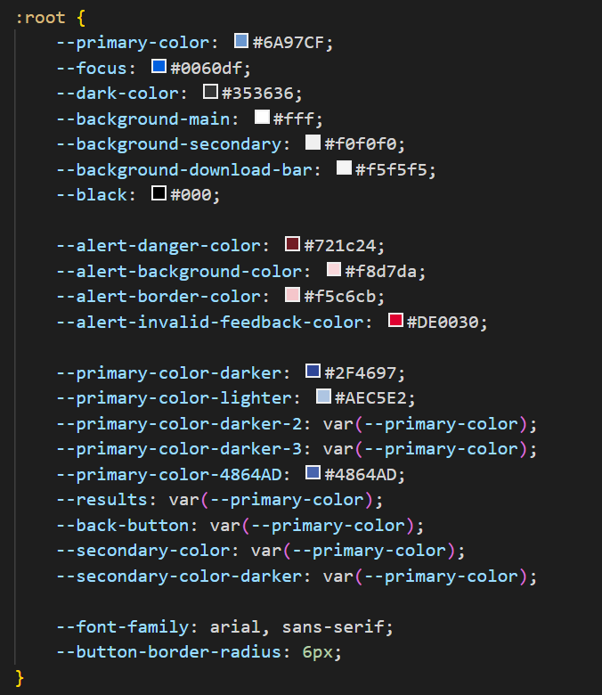
Figure 12: Declaring the retail trust CSS variables

Reusable CSS Variables
Reusable CSS variables (Figure 13) in the code allowed me to implement design changes efficiently, making tweaks straightforward. This was useful to demo various colour options which would achieve different contrast ratings, during our daily stand up (Figure 14-15). The implementation benefits the tool making by enhancing maintainability and establishes a foundation for future white labelling to streamline that process.

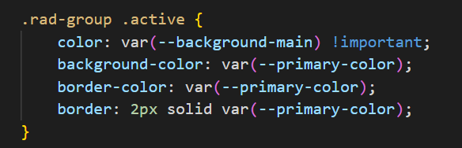
Figure: 13 Using the CSS variables

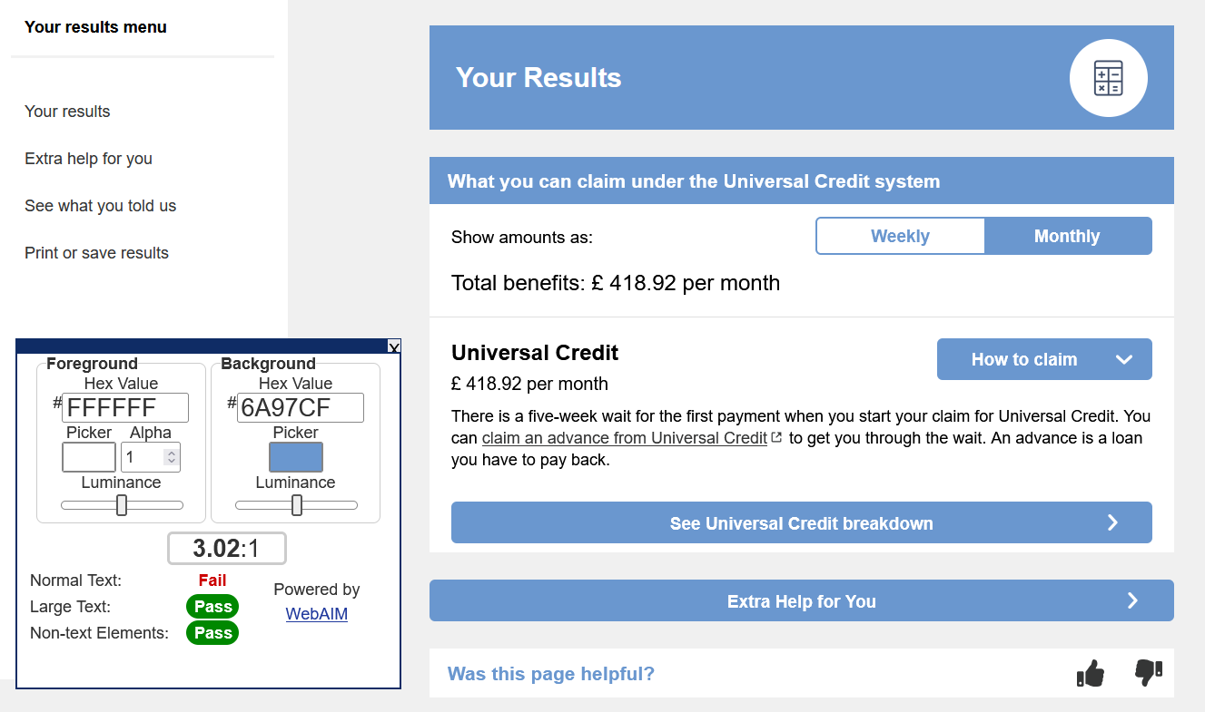
Figure 14: Demoing the main Retail Trust colour and its accessibility colour contrast rating on the results screen.
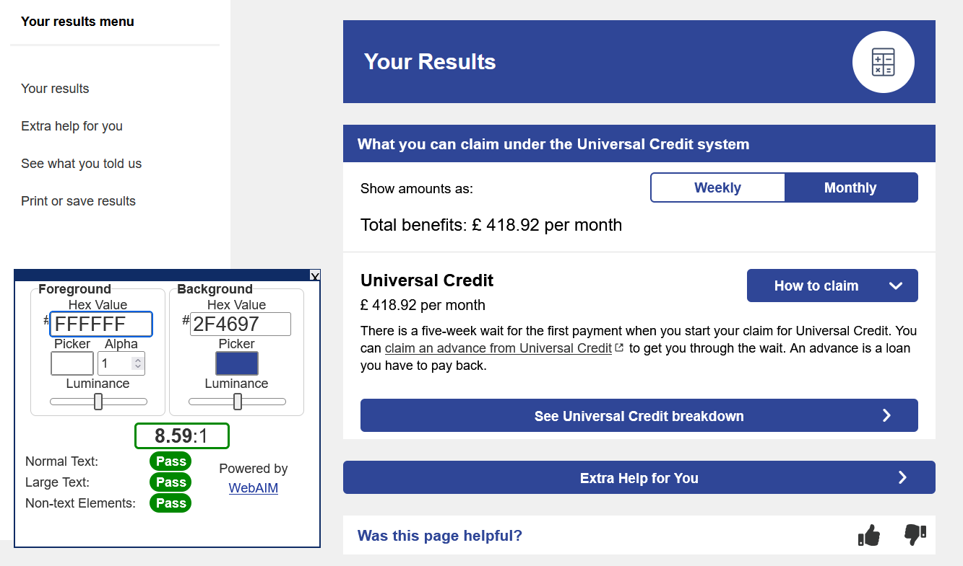
Figure 15: Demoing a secondary Retail Trust colour and its accessibility colour contrast rating on the results screen.

Issue with Border
While I was adding styling to the retail trust version, I noticed an inconsistent border on some of the buttons of my branded version. On investigating this I discovered it was also present on the main tool; it possibly hadn’t been noticed as the border was only 1 pixel but on the white labelled version it was more obvious with a larger border of 2 pixel and rounding at the edges (Figure 16-17). I could find the code causing this issue, using the browser tools which let me locate it in the code base (Figure 18).
To resolve this, I set out to find a solution to fix this on the main tool, ensuring that my branded version would also be corrected. What complicated this task was that this element had the structure of a label then a check box. So, selecting label + label in CSS would not work. During my research online I found the option of using a tilde selector (~). A tilde (~) selector allows selection of subsequent siblings that are not necessarily immediately adjacent. I applied this fix to the main.css file and this displayed the border correctly on the main tool and the retail trust branded version (Figure 19-20).

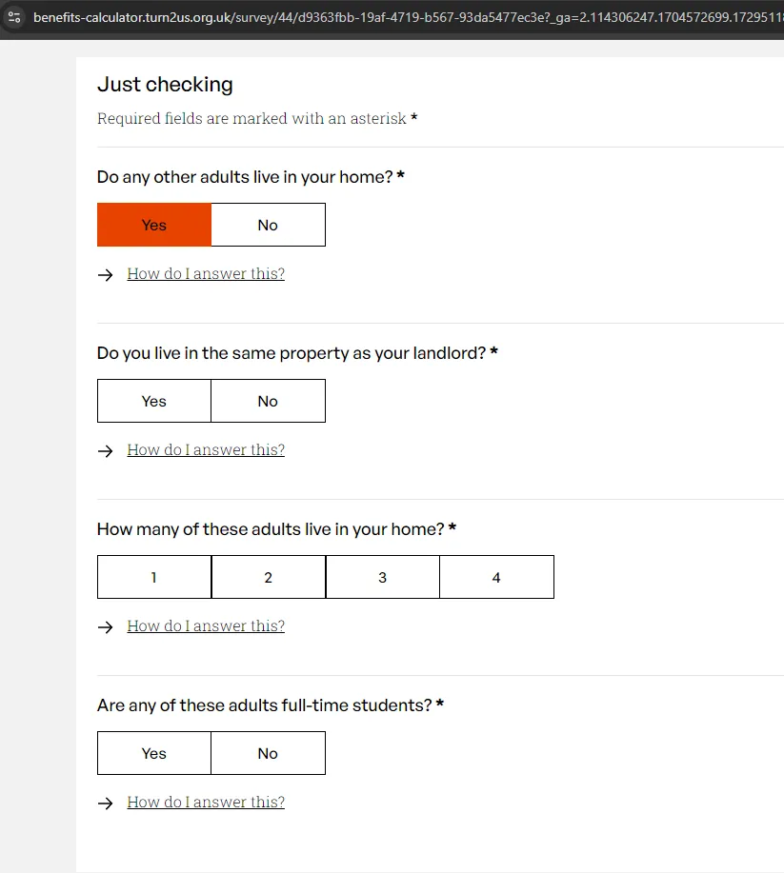
Figure 16: The main tools incorrect border between 1-3
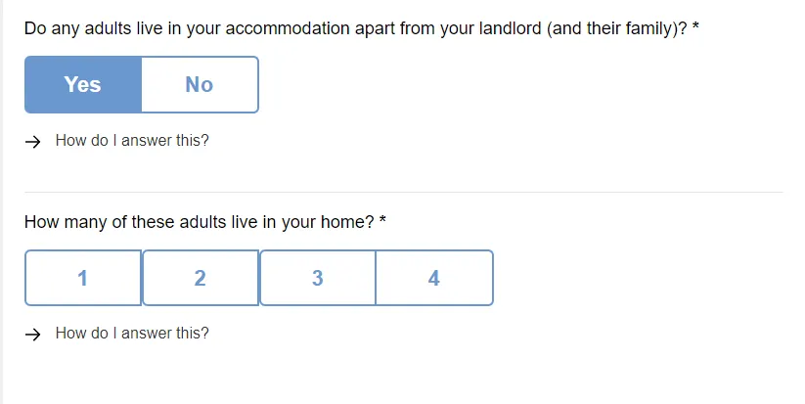
Figure 17: The more obvious issues on the white labelled version with border and rounding

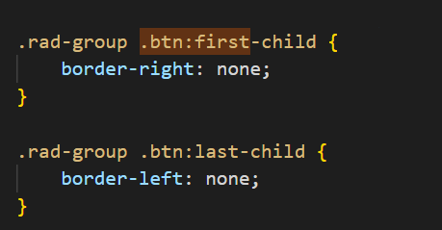
Figure 18: The existing CSS code responsible

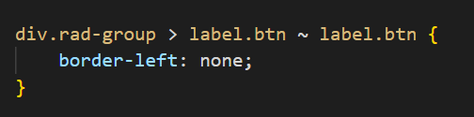
Figure 19: The new code with the tilde selector in main.css

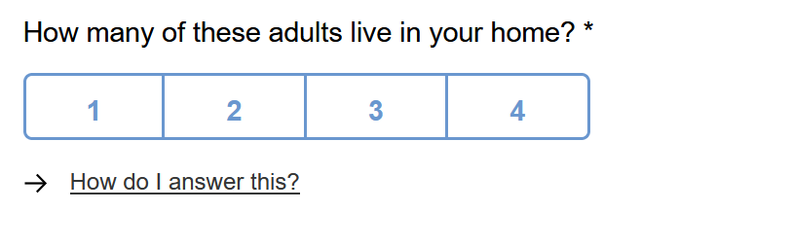
Figure 20: The new CSS showed the options with consistent borders and radius at the ends on the white labelled version.

Issue with Download Bar of Previous White Labelling
While reviewing the design of the previous white labelling for CAP I noticed an inconsistency in the styling of the download progress bar (Figure 21). This issue arose because a progress tracker had been added to improve accessibility of the download button but after the CAP white labelling had finished. It had been an oversight that the new CSS selectors for this element had not been applied to the CAP CSS sheet. I was able to resolve this by adding the correct code to the CAP CSS sheet, ensuring consistency in the design (Figure 22-23).

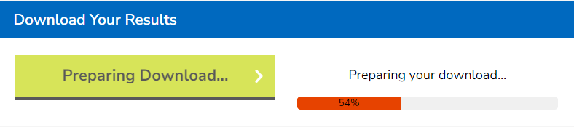
Figure 21: The incorrect colour for the download bar
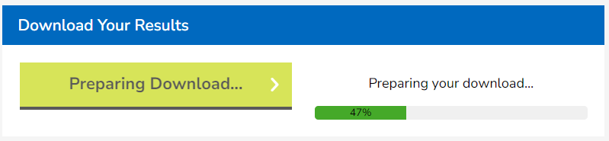
Figure 22: The fixed download bar matching the CAP styling
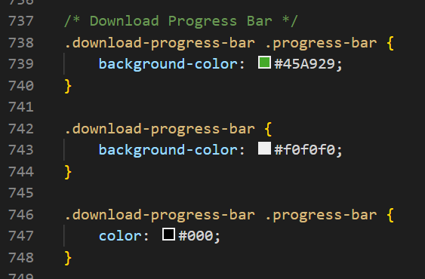
Figure 23: The code I added to cap.css

Daily Stand Ups, Testing and Deployment
As I was working, I kept my colleagues up to date with my progress in the stand ups. This allowed me to demo the work and ask any questions that I needed. Our stand ups include a non-technical member of staff (benefits specialist) so I would stay on the end of the call with my manager to discuss any highly technical queries.
As my work progressed, I moved the ticket to the Ready for testing column in Jira. This work was to be shared with an external partner, but it was tested internally first. For this to be easily tested it was deployed to the UAT environment.
As a part of internal testing, I gave a demo and presentation of my work to my manager and the head of digital. Once they were satisfied the UAT link was shared with the external partner for them to begin testing.

Deployment conflict in UAT
My code was successfully deployed to UAT; however, a colleague later deployed a different branch to the same environment, inadvertently overwriting my changes. The UAT link had already been shared with the retail trust, so when trying to test it they got an error. They contacted the head of digital, to report this issue. We quickly redeployed the correct code fixing the issue, but this made us look unprofessional.
To mitigate such risks, we discussed having clear communication regarding deployment across environments in the stand ups as our development team increases in size. Additionally, the need for implementing CI/CD pipelines and GitHub pull requests was explored to enhance our workflow and prevent similar occurrences.

Accessibility Issue with Small Screen Menu Navigation
While checking keyboard navigation on screens below 1200px, I noticed unexpected behaviour in the main tool’s menu. At this size, the menu collapses into the word “Menu” alongside an icon. When I navigated via keyboard there was no visible focus on the icon, and the hidden menu items remained keyboard focusable.
To address this, I raised a Jira ticket for this issue with details and pictures and left it in the backlog for future work (Figure 24). I also raised this issue in the Teams chat as the tool was about to be retested for accessibility (Figure 25). This ensured the team was aware of this new ticket and meant they could bring it into the current epic or prioritise it in a planning session.
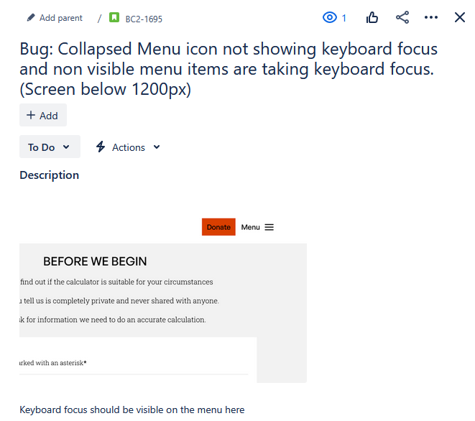
Figure 24: The Jira ticket I created for the menu bug

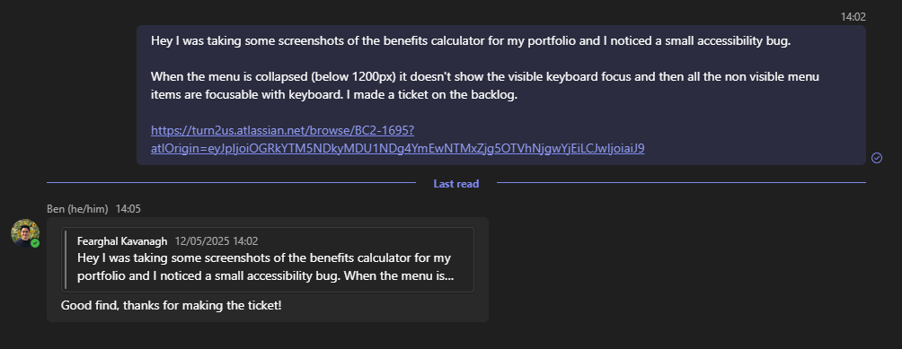
Figure 25: My message in the Teams chat for the BC team.

Lighthouse Accessibility Testing
When I was nearing completion of this piece of work, I tested the accessibility using chrome’s lighthouse tool. I discovered that I had to adjust the font weight I had applied to 700 to ensure it was sufficiently bold and met the requirements. After making this adjustment, the site achieved a 100% accessibility score on lighthouse (Figure 26).
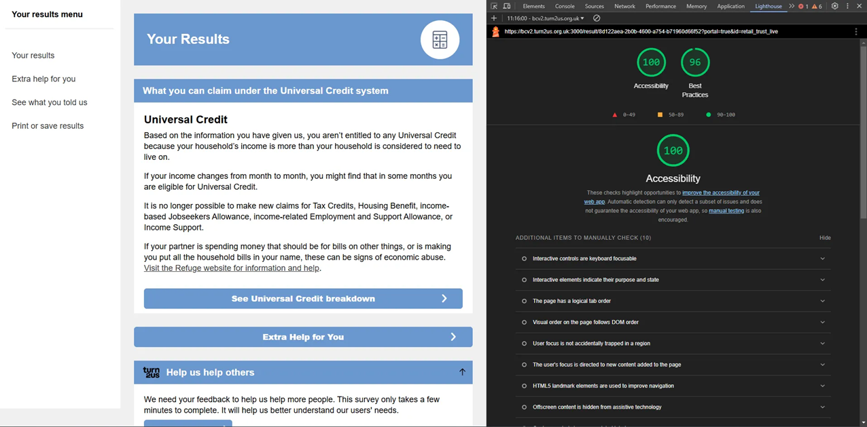
Figure 26: Lighthouse result on the results screen

Results:

CSS Variables
The CSS variables proved highly effective, enhancing both code maintainability and flexibility. My colleagues and fellow developers responded positively to this approach, recognising its potential to streamline styling adjustments.
Moving forward, we plan to expand implementation across BC and other Turn2us tools. Additionally, these variables could help avoid issues such as the downloading style bug in the CAP portal version. By using dedicated variables for white labelling while keeping selector code centralised in the main.css file, we could significantly reduce theme file code duplication, and the codebase would be easier to maintain.

    - Presenting My Work
On completing the work, I presented this to my manager and the head of digital. I prepared a comprehensive document to showcase my work, considering how best to communicate my process and findings. During my training bootcamp, I presented my work every week, so I felt confident giving this presentation. Since my manager is a software developer and the head of digital comes from a project management background, I aimed to balance technical accuracy with accessibility by ensuring my explanations were clear without unnecessary jargon.
To start, I gave a demo of the white labelled tool, providing an overview of its functionality. I then walked them through a detailed document outlining my approach. This document explained the structure of my code, the challenges I encountered, and the solutions I implemented. The head of digital does not attend our standups or planning meetings, so I made sure to clearly explain the reasoning behind key decisions. All code snippets were accompanied by visual demonstrations, such as screenshots showing the implemented features in action (Figure 27). The feedback was positive, and I was pleased that the head of digital found the presentation informative.

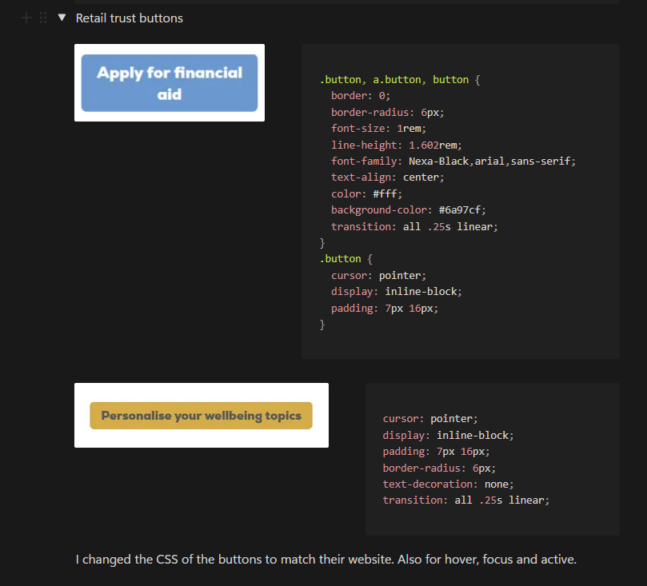
Figure 27: I included code snippets to illustrate code

Retail Trust
Once the deployment conflict was fixed, the head of digital shared the UAT link with the Retail Trust for testing. The UAT version featured their white labelling. She coordinated with her contact there, who reviewed the tool and requested some minor tweaks to the result page. These changes were implemented quickly and approved by the Retail Trust.
Following their approval, the ticket on Jira could then go from testing to passed test, moving into the for deployment column. Once deployed to the production version of our tool, the ticket was placed into the done column, completing its journey through Jira.

Knowledge matrix
ID | Knowledge | Section
K1 | All stages of the software development life-cycle (what each stage contains, including the inputs and outputs). | 3.4-3.6
K4 | How best to communicate using the different communication methods and how to adapt appropriately to different audiences. | 3.5.5  3.6.2
K7 | Software design approaches and patterns, to identify reusable solutions to commonly occurring problems. | 3.4.5  3.5.1-3.5.2
K8 | Organisational policies and procedures relating to the tasks being undertaken, and when to follow them. For example the storage and treatment of GDPR-sensitive data. | 3.4.1  3.4.3  3.4.8
K12 | Software testing frameworks and methodologies. | 3.5.8

PIP helper tool and the Accessibility Menu

Overview
The PIP helper tool was built with accessibility in mind and once it was finished, we had this audited. Another charity carried out the accessibility audit against WCAG level AAA. We aimed for level AAA rather than the typical level AA as this tool is designed to help people apply for a disability benefit. When they delivered their report to us, they had some recommendations we needed to meet to achieve level AAA. In our planning meeting the product manager generated tickets based off these and grouped them in an epic. One recommendation was that users can change the appearance of the tool to make it more accessible to their needs. This spurred the development of the PIP accessibility menu.

Stakeholders
PIP Team - responsible for development and implementation of accessibility features and WCAG compliance
Head of digital - project oversight and strategic approval for accessibility investment and compliance standards
UX/UI Designer - design and user testing of accessibility menu and customisation features
Brand Team - ensuring accessibility customisations align with brand guidelines and visual identity standards

Skills matrix
ID | Skills | Section
S2 | Develop effective user interfaces. | 4.5.3
S8 | Create simple software designs to effectively communicate understanding of the program. | 4.5.2
S15 | Communicate software solutions and ideas to technical and non-technical stakeholders. | 4.6.4
S17 | Interpret and implement a given design whilst remaining compliant with security and maintainability requirements. | 4.5.6

Behaviour Matrix
ID | Behaviours | Section
B1 | Works independently and takes responsibility. For example, has a disciplined and responsible approach to risk and stays motivated and committed when facing challenges. | 4.5.2
B4 | Works collaboratively with a wide range of people in different roles, internally and externally, with a positive attitude to inclusion & diversity. | 4.5.6
B6 | Shows initiative and takes responsibility for solving problems within their own remit, being resourceful when faced with a problem to solve. | 4.5.5
B7 | Communicates effectively in a variety of situations to both a technical and non-technical audience. | 4.6.4
B8 | Shows curiosity to the business context in which the solution will be used, displaying an inquisitive approach to solving the problem. This includes the curiosity to explore new opportunities, techniques and the tenacity to improve methods and maximise the performance of the solution and creativity in their approach to solutions. | 4.5.5-4.5.6

Planning

PIP Team Planning Meeting
We had a group discussion in the planning meeting to interpret the report recommendations (Figure 28). We had a lot of discussion on what was meant with “foreground and background colours can be selected by the user”. Did they mean that a user would be able to select any colour they wanted for each? We tried to find examples of where this has been implemented and decided to make some dedicated themes instead. A Jira ticket was created for the menu; my manager and I split it into smaller tickets and divided the work between the two of us. This allowed us to work at the same time and know which elements we were responsible for.
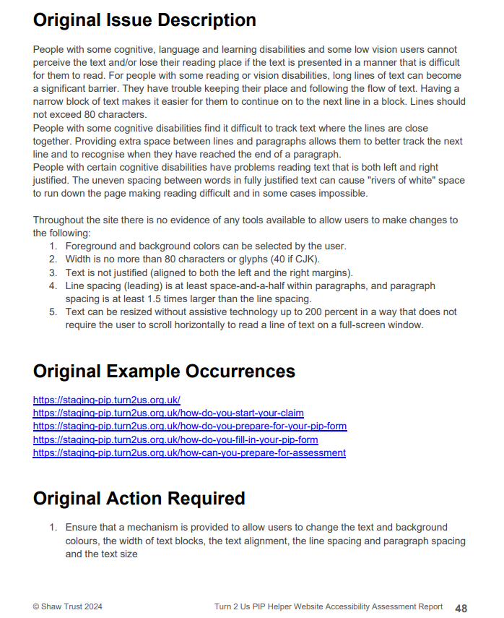
Figure 28: The recommendations to make the make the tools visuals adjustable

Examples
We looked for examples and shared them in the meeting, so we could discuss how other websites had offered similar options. I shared my screen and showed examples that I had found, and we discussed what would be suitable for our tool (Figure 29). I planned what the tool might look like on desktop and mobile. I based my design off a mixture of some of the good examples I found and that the team liked. I needed to move the audio narration option into the menu as it was currently located on the side navigation bar.

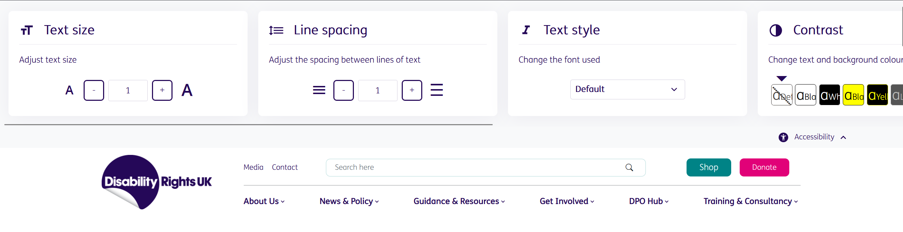
Figure 29: A good example of an accessibility menu we found

Frontend code architecture
In a call with my manager, we discussed ways of setting up these code changes. We would need React components, it would need to save user preferences, and it would need to adapt to mobile. Keyboard and screen reader accessibility also needed to be considered. We planned to make the menu button, the main menu, and each of the options as components. We would also need context to persist the users’ preferences across the website. I had learned from earlier work I had done on white labelling the BC that we would be able to use CSS variables to change the colours, font styles, sizes etc.

Task Implementation

Set Up
I created a GitHub branch for this in the frontend repo called AccessibilityMenu-Update, to follow version control and to allow the collaboration with my manager.

React Components
I made the React components in the components folder for TextResize and the ThemeSelector. I used context to save the user preference across the entire tool. To persist the user preference, I used local storage for the context and checked this in the context for each when initialising. The configurations were saved in the context file (Figure 30). The component then maps each menu option to make the visual elements, in this case 100%, 125%, etc (Figure 31). The main menu component iterates through an array of objects, which contain the components to render the full menu structure. This approach enhances modularity by isolating each accessibility feature into its own context and component, which increases reusability and maintainability. It also enabled my manager and me to collaborate effectively on the project simultaneously as the clear separation of concern across files allowed us to work on different components without conflicts.
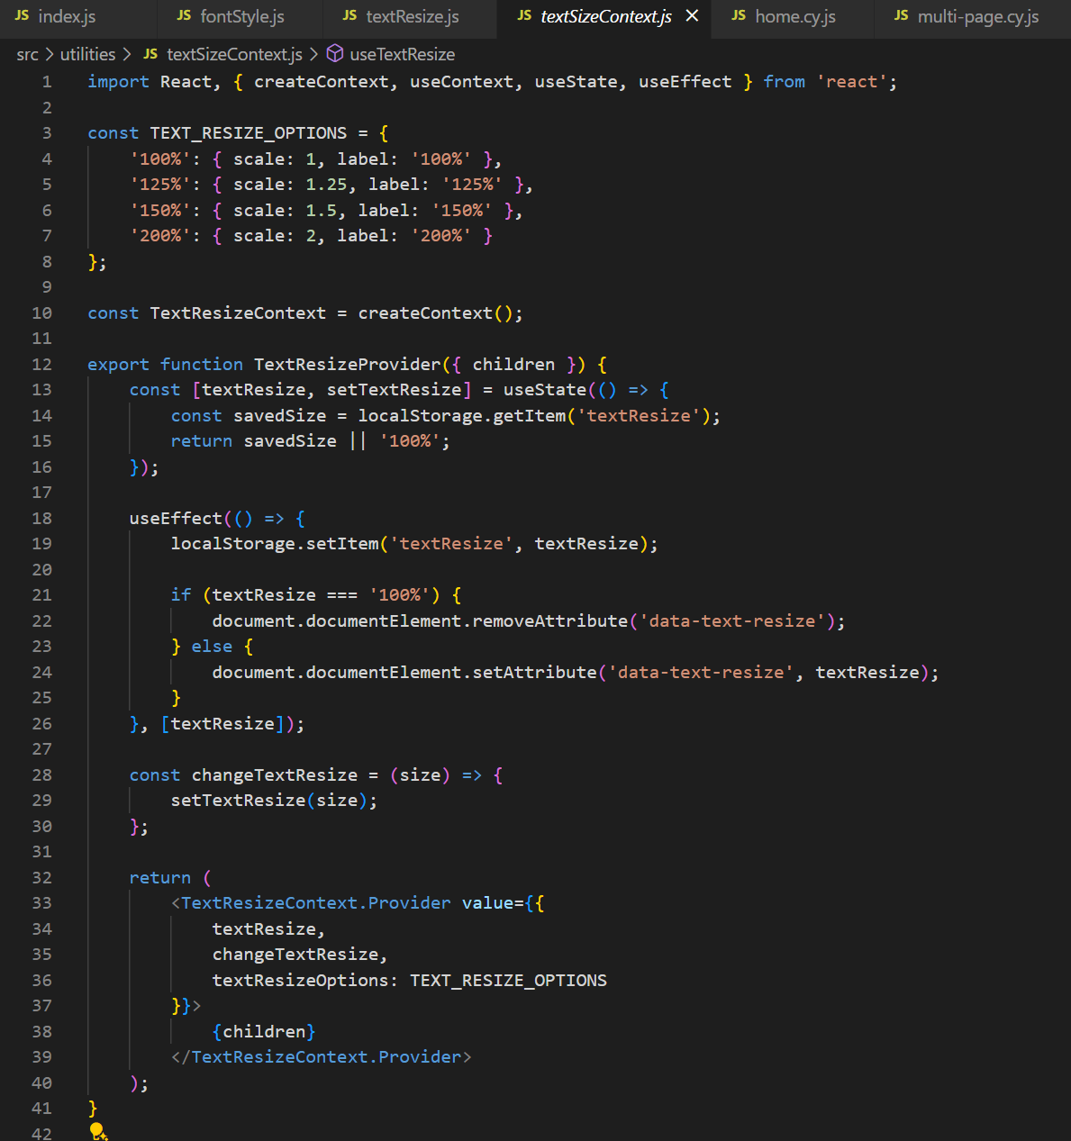
Figure 30: The React TextSizeContext code.

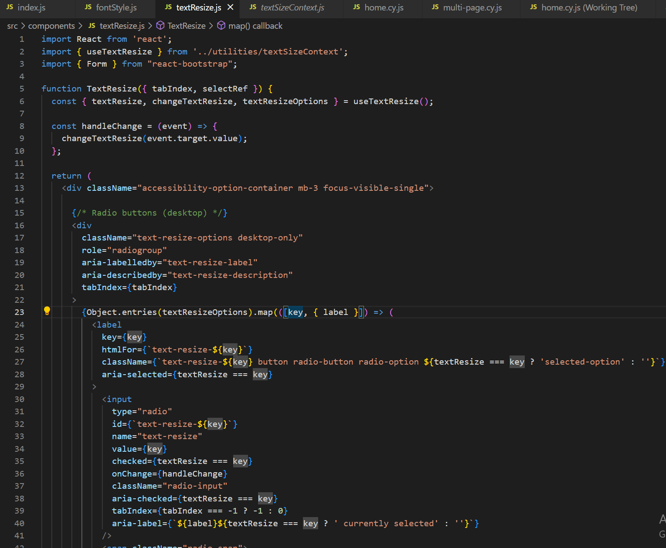
Figure 31: The TextResize Component

Iterations of the Menu
While I was working, I tested on my local machine to ensure it behaved as expected and when it was satisfactory I deployed it to staging, as there were other features being tested on UAT that would be deployed on a shorter timeline. This allowed the entire team to test the new menu and features.
I used the daily stand ups to iterate on the menu as needed. I asked for feedback from my colleagues and then implemented design changes based off their suggestions. The product owner made final decisions if there was no consensus. My colleagues had suggestions to keep the design more uniform with the rest of the tool. To make the buttons a uniform size and colour, to ensure all the space was being used, and to show a preview of the text sizes and font styles like the theme selector. (Figure 32-34)
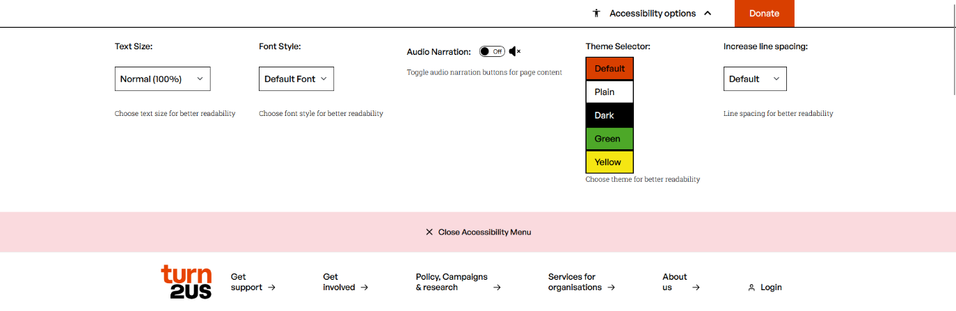
Figure 32: An early iteration of the menu

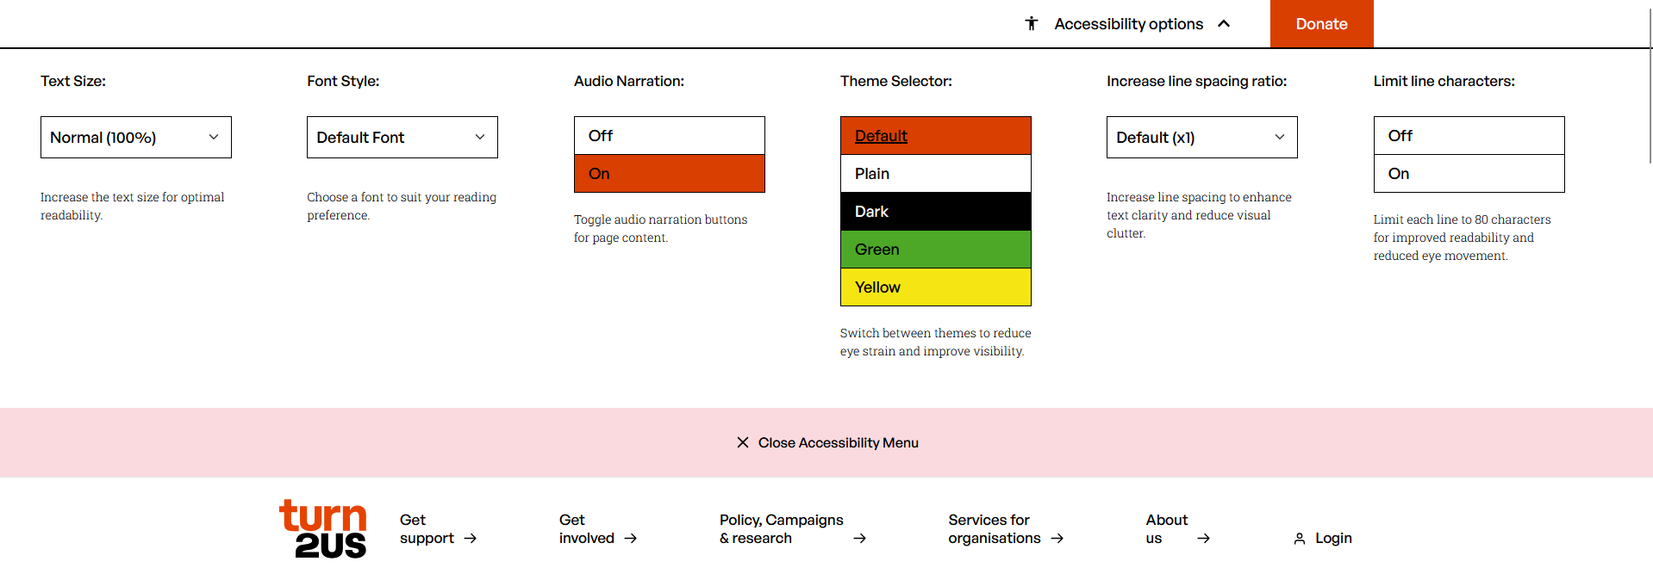
Figure 33: After adjusting using feedback from the daily stand ups

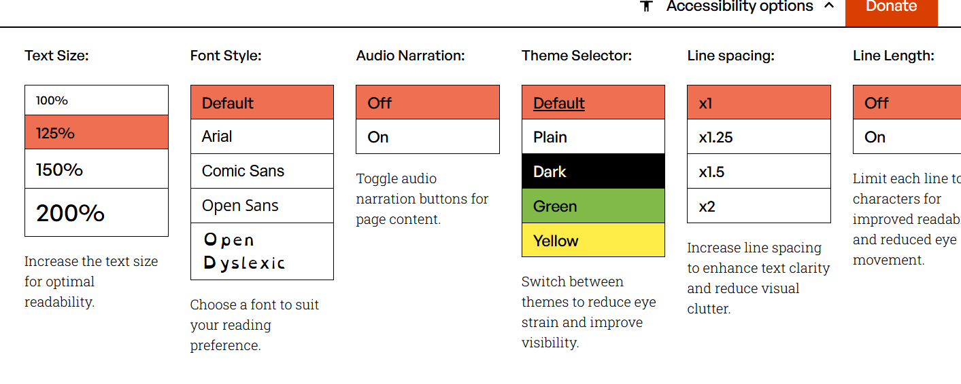
Figure 34: A much later iteration with text size and font style showing previews on each button.

Theme CSS
The themes for CSS required a lot of work and consideration. I audited the CSS files and noted every colour that I found used. Then I was able to make a default theme using these colours and I assigned them CSS variables. I then started to reassess the CSS files, and I applied these variable names instead of the hex colour codes. Once this was completed, I confirmed the tool had no visual changes by inspecting it and comparing it to the production tool.
I then experimented with an inverse colour palate to make the dark theme. After this I was free to make the other themes of plain, green, and yellow. In researching the colours that we should offer, dark was suggested as good for light sensitive users, or users reading at nighttime. The green and yellow would be good for users with neurodivergence, such as sensory needs or dyslexia.

Issue Keyboard Focus
When working through the CSS, I was trying to group similar CSS together and I found that the keyboard focus had nine different styles across the PIP helper tool. In the daily stand up, I demonstrated this to the team members, and the product owner decided which keyboard focus would be best and consistent with our brand. (Figure 35)
Our branding team is due to provide us with an updated style guide to help with issues such as this, as we currently don’t have an official keyboard focus. I was able to log this issue in a document that we are keeping to aid them in their digital brand review.

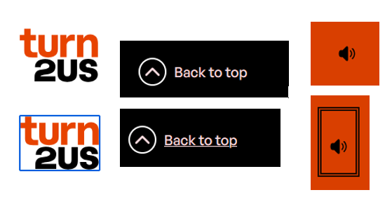
Figure 35: These are three examples of the keyboard focuses found on the tool (the lower image has the keyboard focus for each). A blue box, a pink underline and a double black outline.

Head of Digital and the UX/UI Designer
My manager demoed the work to the head of digital in their weekly meeting. The head of digital was surprised by the menu and its unusual options, so they requested that the UX/UI designer review and approve the work. The UAT link was sent to the in-house UX/UI designer who then reviewed it and the report, but without the context of the research I had done he reached out for a meeting.
My colleagues are very committed to accessibility, but they assumed that meeting the high contrast visual requirement would be the end of our work on colours and themes. I had to explain the need for themes that are useful for people with neurodivergence or light sensitivity. These different options could help reduce the mental load and allow the user to read more. (Figure 36).
Once the reason was clear to the wider team they got on board. Discussion moved to how to help as many people as possible with an intuitive menu interface.
The UX/UI designer was happy with the implementation so far but suggested that I make it easier for users to tell which theme is selected. We settled on adding an underline to the theme which the user has selected.

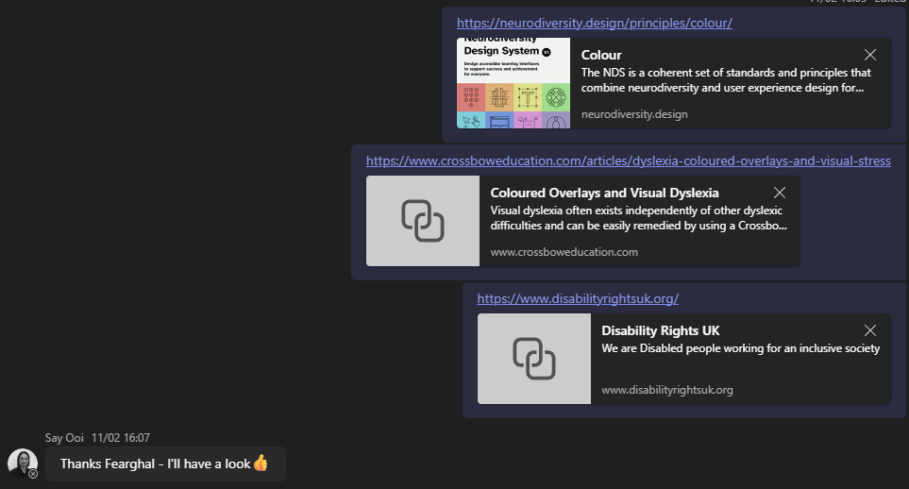
Figure 36: I supplied the UX/UI designer with some of the links to research I found useful

Branding team
We notified the branding team of the use of non-standard styles to explain that this tool was to be made to WCAG level AAA. It would likely only be used by specific users who found it useful, and the non-standard styles would be confined to the options for example themes (dark, plain, green and yellow).
Once the changes were approved internally it was decided that we would keep it on staging and send it to be retested for accessibility before releasing to live. The report did find an issue where the menu when closed wasn’t hidden from keyboard focus, but didn’t have any actual feedback on the implementation of the menu.

Issue with Screen Reader
On retest, the menu was showing in screen readers element list even while closed (Figure 37). While fixing this error I used screen reader software (NVDA) to test the website by navigating with my keyboard. I wanted to view the element list, so I used a shortcut (Insert and F7) which showed me the menu I needed to see to fix the issue the retest had found (Figure 38). I had to add a hidden aria-label to the menu while it was closed so it wouldn’t appear as an option in this menu. (Figure 39) An aria label provides a descriptive name for an element to assistive technologies such as screen readers.

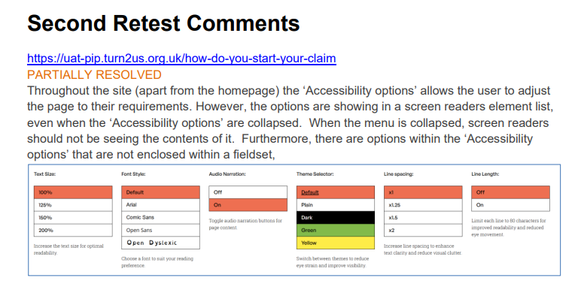
Figure 37: Second retest, menu options not mentioned by issue for screen readers found

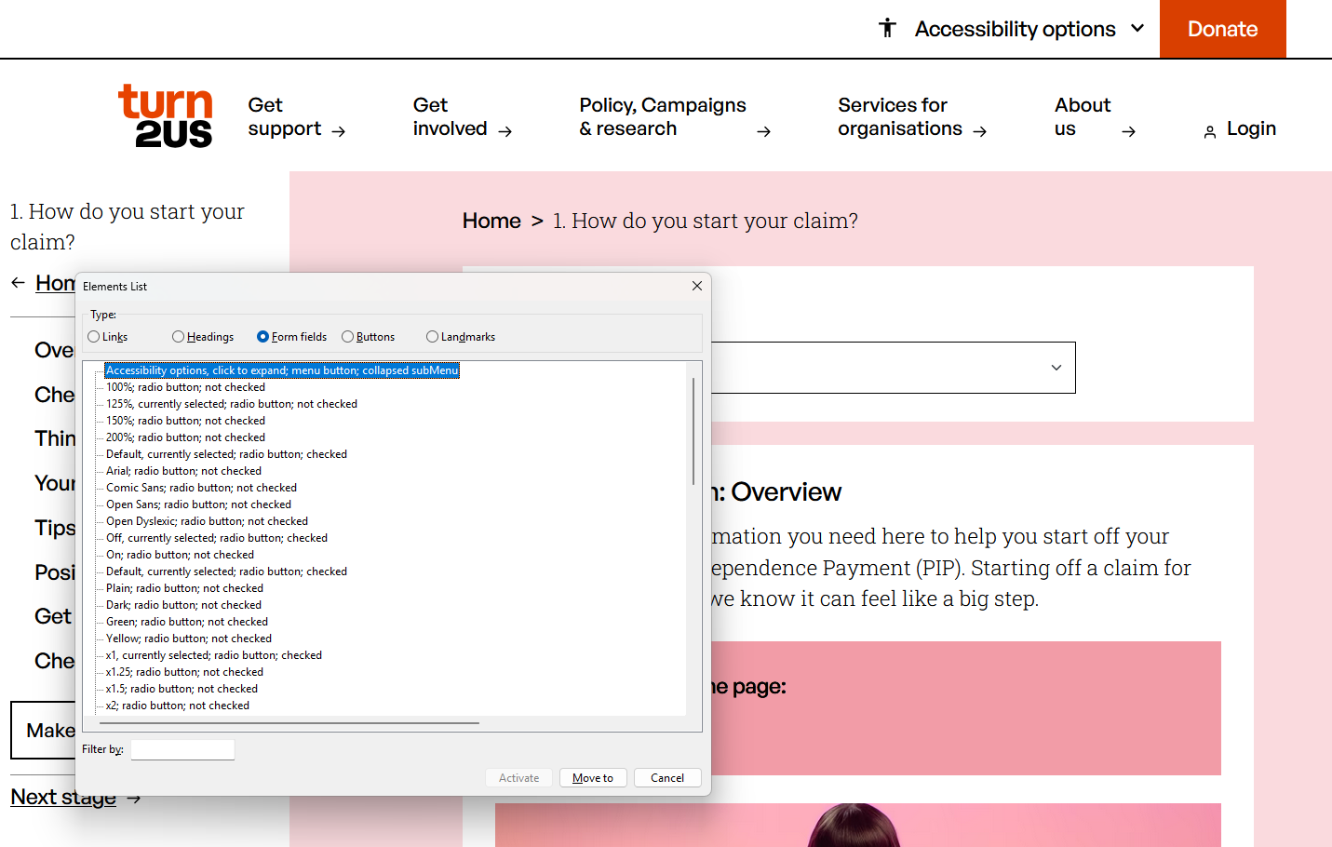
Figure 38: I replicated the issue using screen reader software
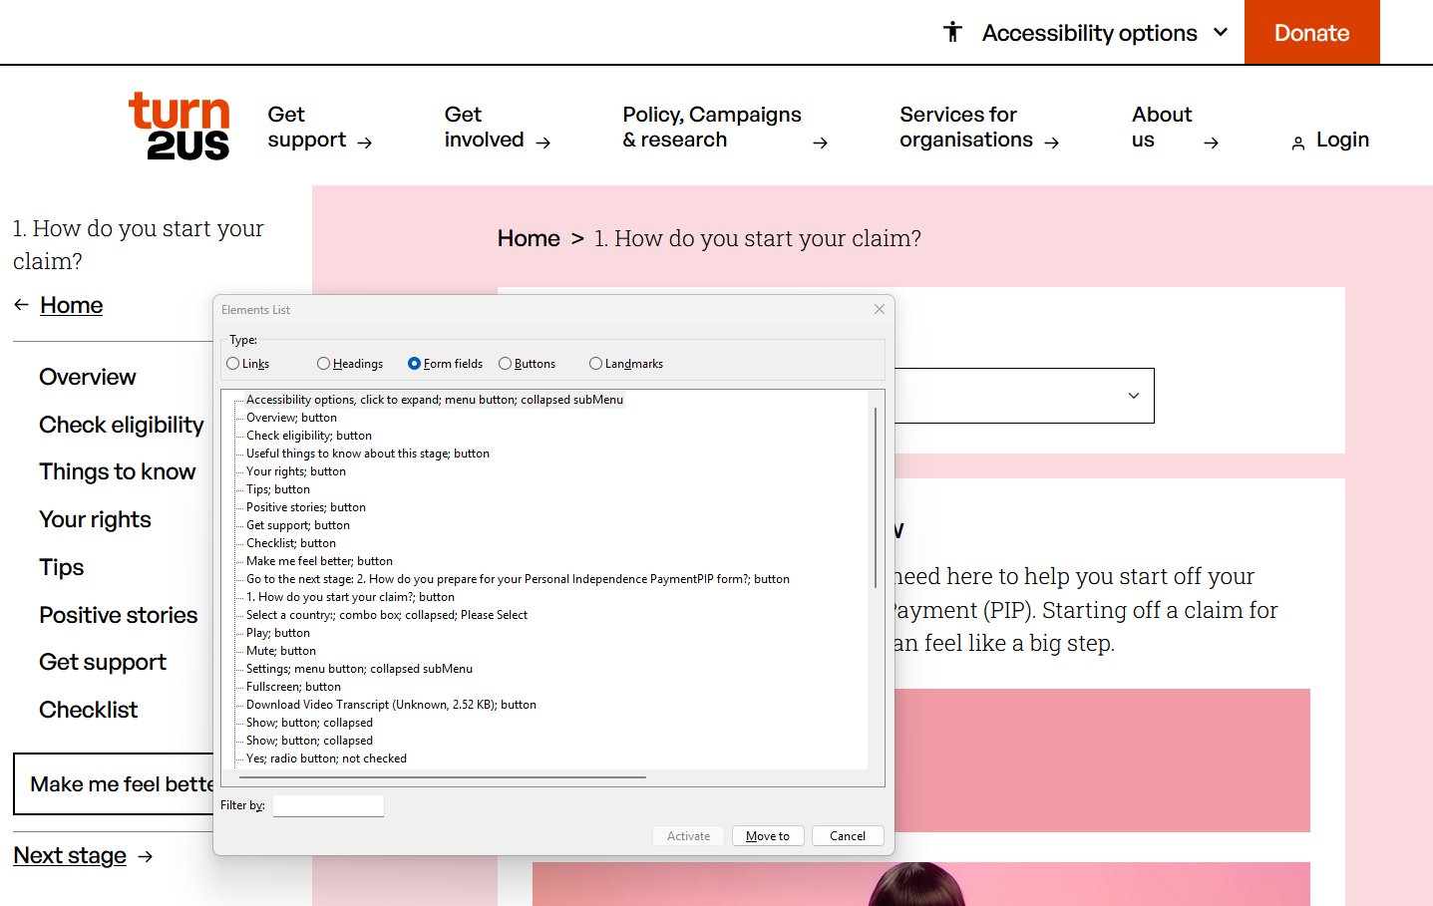
Figure 39: After I fixed the issue the menu options are no longer visible when the menu is closed

Results

Audit Retest Meeting
Following feedback on the Menu that was limited to the screen reader navigation issue, we requested a meeting with the Shaw Trust to discuss the retesting results. The Shaw Trust expressed that they were impressed with the implementation and very satisfied with the menu functionality. A final retest is pending to confirm the rating, as other outstanding issues have since been resolved.

Live Users
The menu is currently deployed in our live environment where users can actively engage with it. To understand how it's being used, we have plans to implement comprehensive tracking through Hotjar for user behaviour analysis, Google Analytics for usage metrics, and targeted surveys to gather direct user feedback.

Branding
The branding team has listened to the need for accessibility brand guidance and are working on it presently. They have also set up documents for us to report issues. They have a contact in the digital team who they will liaise with. In addition, they have set up a committee with employees from across the company to offer feedback on the changes and the proposed changes are due soon.

Head Of Digital and the Lightning Talk
The head of digital was impressed with our work and put us forward to give a lightning talk at our company away day. The talk was to be given by my manager and me. The presentation would be to all our Turn2us colleagues and our co production partners. The lightning talk was seven minutes long, with an extra three minutes for questions at the end.
My manager and I created a shared PowerPoint and divided the presentation, so he handled the first half while I covered the second half and fielded the questions. We made our presentation more interactive by adding a QR code directing viewers to the PIP tool, allowing them to explore the accessibility menu as we talked and demoed the tool (Figure 40). It was important to have emphasis on our values at Turn2us so we talked about working with another charity and making our tool accessible to all, which demonstrated our value of Financial Security for All. We tailored our language to be clear and straightforward for an audience without technical backgrounds.

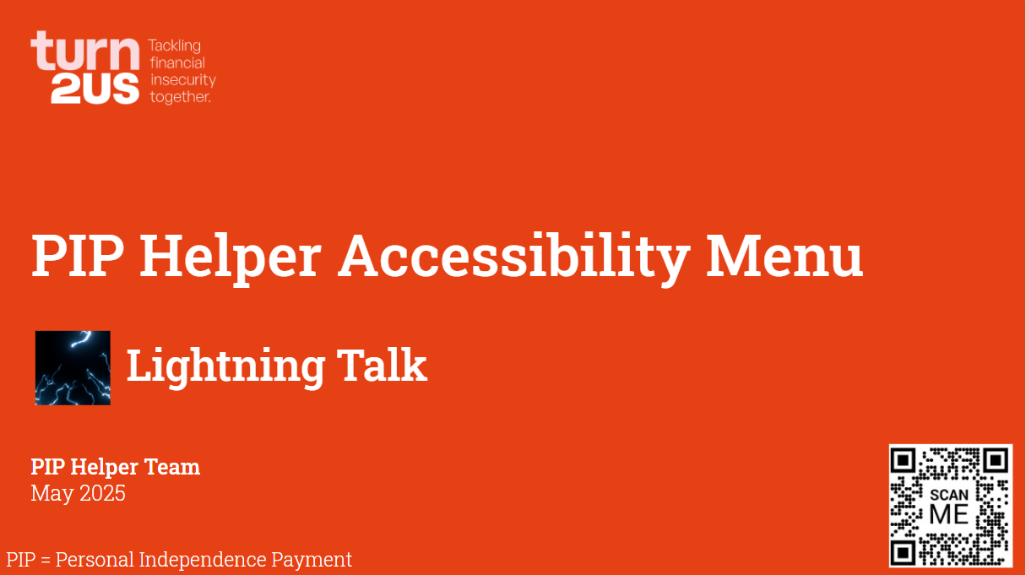
Figure 40: The title page of our lightning talk with the QR code

Knowledge matrix
ID | Knowledge | Section
K4 | How best to communicate using the different communication methods and how to adapt appropriately to different audiences. | 4.6.5
K7 | Software design approaches and patterns, to identify reusable solutions to commonly occurring problems. | 4.5.5

BC War pensions

Overview
I was assigned the Jira ticket to develop a dedicated page of questions for the BC. In a planning meeting, the product owner decided to move this piece of work from the backlog into the sprint and create an epic for it, as it was likely to take longer than one sprint. A question already existed for war pensions, but this work would expand it to an entire page, allowing users to input more detail and receive enhanced information on the results page.

Stakeholders
BC team - daily collaboration and feedback on development progress and requirements refinement

Skills matrix
ID | Skills | Section
S3 | Link code to data sets. | 5.5
S17 | Interpret and implement a given design whilst remaining compliant with security and maintainability requirements. | 5.4.2

Behaviour Matrix
ID | Behaviours | Section

Planning

Initial
For the benefit calculator we use an excel sheet to store much of the content and configuration of the frontend. We have a React frontend which has some text hard coded, but only elements that are unlikely to change. In the backend we use C# and .NET and these look for the variable names in the sheet to generate all the content (pages, questions, options, messages) and to track answers based on these variable names. The sheet is uploaded to an admin portal that is generated by the backend.
I examined the current code and followed some examples of how other questions were coded. All the questions are set up in the backend in a constant class called QuestionConstants. These are then accessed via the ResultHelper class.

Documentation
The benefit specialist provided me with two documents to accompany the Jira ticket and I linked these to the Jira ticket for future reference (Figure 41). The first document detailed which questions to delete, the page to add and the questions for this page.

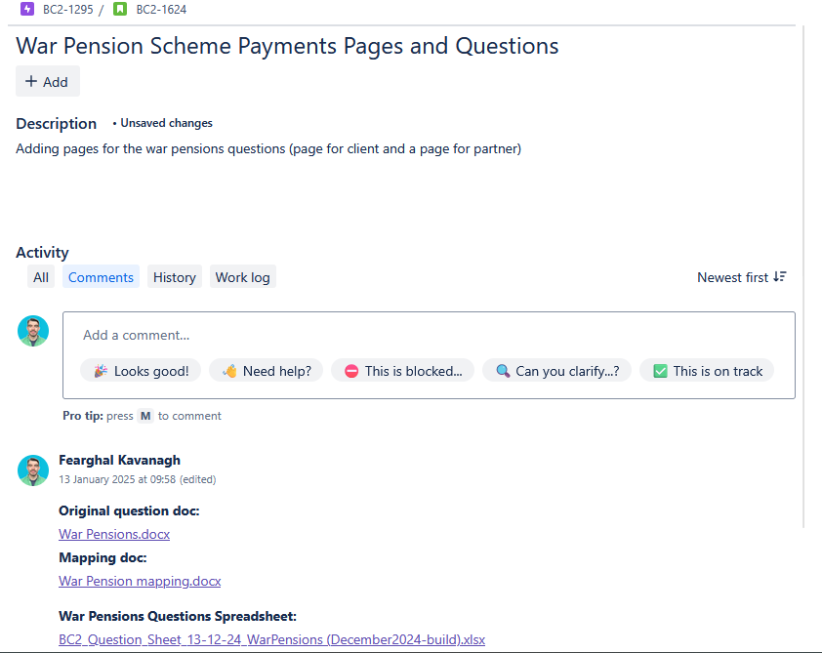
Figure 41: The Jira ticket with attached documentation

Benefit Specialist User Stories
The Benefit specialist had very specific user story scenarios related to the benefits system, to check that the calculator was giving the current information and amounts for users, which they wanted to test once the changes were made to validate the additions.

Task Implementation

Sheet changes
I created a clearly labelled version of the Excel spreadsheet, making it easy to distinguish between the current live version and the one containing the new changes. Any changes that need to be made immediately need to be made to the live sheet and the war pensions sheet, to ensure when the war pensions went live, we kept all work that had been done since the sheet was diverged. This is a limitation of this method of storing data.
I followed the documentation that I was given to make the changes. On the sheet I removed the two single questions (client and partner) (Figure 42), added the new page with the questions, and added options to the options sheet (these are options for the select questions i.e. yes, no or to select a type of war pension) (Figure 43-44). I had to make backend changes to pick up these new variables I had added to the sheet (Figure 45). I added the names to the QuestionsConstants.cs file, I made enums to correspond with the select questions answers, and added code to the ResultHelper.cs file to allow the new constants to be used.
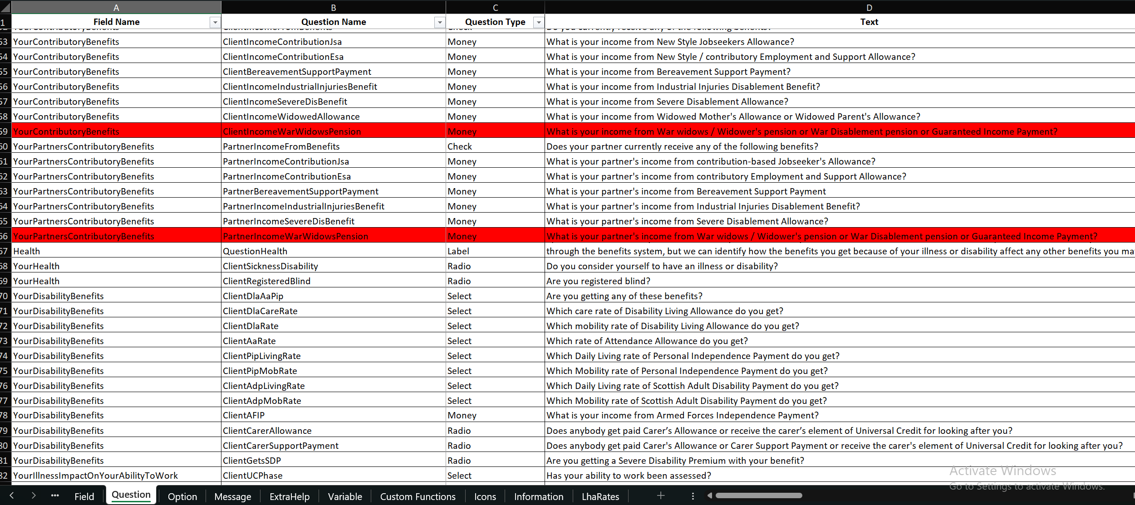
Figure 42: Questions to remove were marked in red

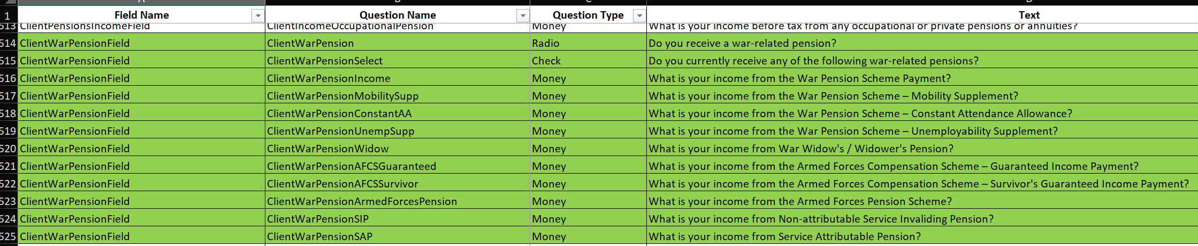
Figure 43: The new set of War Pensions Questions I added

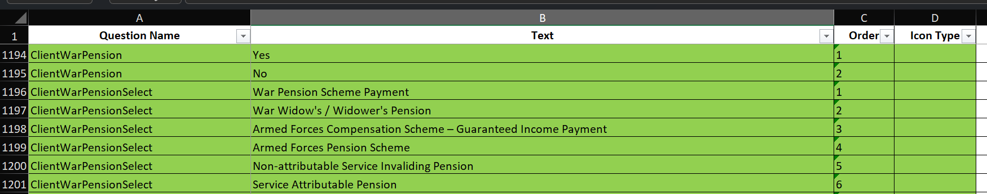
Figure 44: The answer options for the radio and check question types to display

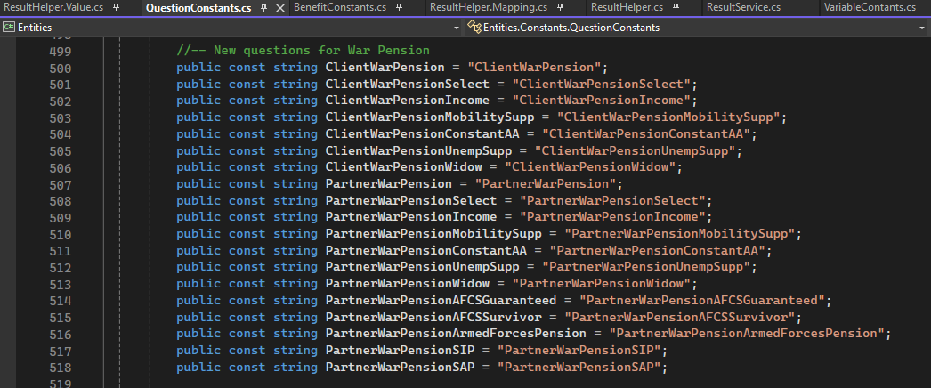
Figure 45: The backend variables matching the sheet exactly

Sheet upload
I uploaded the sheet in an admin portal of the backend, which allows deployment to staging, UAT or production environments. The backend contains a file called ExcelHelpers.cs which handles the upload process.
For example, the BuildQuestionEntities function makes a list of questions, by first locating the QuestionSheetName and then iterating through its contents (Figure 46). It extracts the parentName (FieldName) for each question, which serves as the foreign key. The function extracts the question name, creates a new QuestionEntity, and then populates it with additional information from the sheet including QuestionType, ShowHide, OrderNumber and Options. The options are processed by BuildOptionEntities which follows a similar pattern to BuildQuestionEntities but specifically handles the option data. Once populated, the question entity is added to the questionEntities collection which is then returned (Figure 47).
This BuildQuestionEntities function is called within BuildFieldEntities, which itself is called by BuildPageEntities, creating a hierarchical processing structure. All questions are stored in a single SQL table, where the FieldId foreign key links each question to its corresponding field, which in turn connects to a PageId through a similar relationship structure.

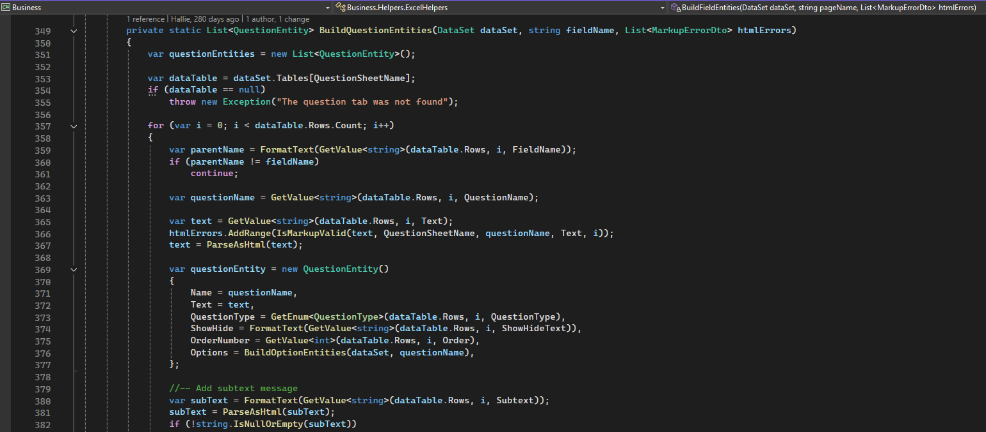
Figure 46: The code which maps the questions from the question excel tab

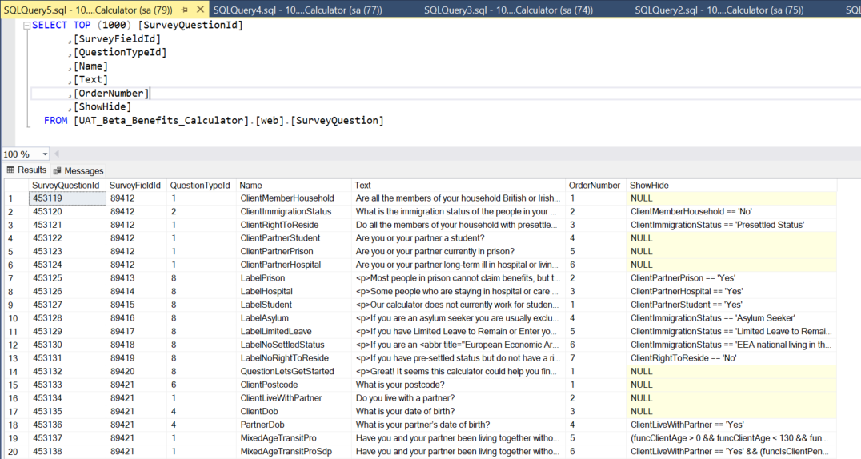
Figure 47: Querying the database you can find the current questions which have been uploaded

The relationship between QuestionEntity and FieldEntity demonstrates a one-to-many database structure (Figure 48-49). In the QuestionEntity class, there’s a property called FieldId, which serves as a foreign key that links each question to a specific field. The FieldEntity class contains a collection (ICollection<QuestionEntity>) named Questions, meaning a single field can contain multiple questions. This collection is an entity Framework navigation column, but this is not stored in the SQL database (Figure 50).
This implementation shows an interesting contrast of relational and non-relational databases. The excel sheet is a non-relational database and was chosen to allow ease of use for non-developers to edit. While this approach has the drawbacks such as a lack of data integrity and issues with version control it provides significant usability benefits.
Once the sheet is uploaded, the data is transformed and separated into different SQL tables. When the sheet contains the correct variable names, it will create the SQL relationships effectively converting the non-relational data into a properly structured relational database. Following the earlier example, questions with matching field names are grouped together and are displayed within their designated field. Fields have the same relationship to pages, ensuring questions appear on the correct pages throughout the application.

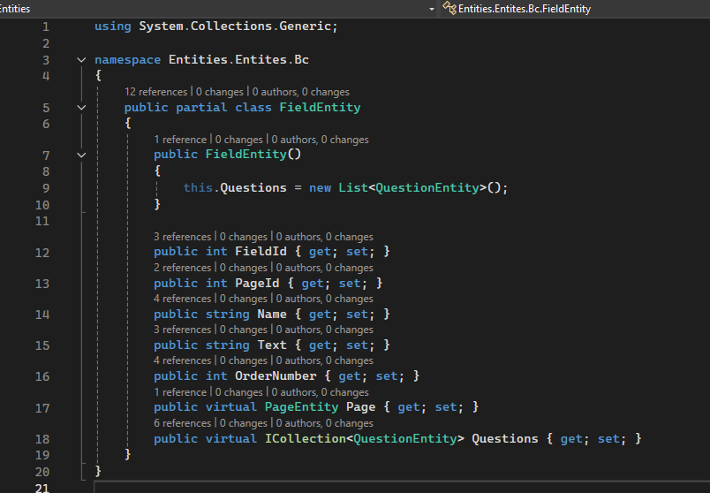
Figure 48: The field entity. Note the last line: “public virtual ICollection<QuestionEntity> Questions { get; set; }”

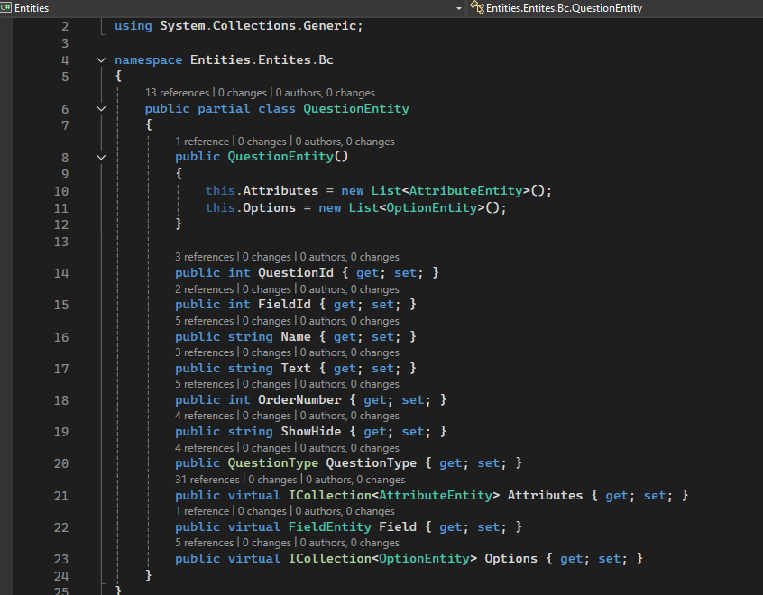
Figure 49: The question entity. Note the line: “public int FieldId { get; set; }” and “public virtual FieldEntity Field { get; set; }”

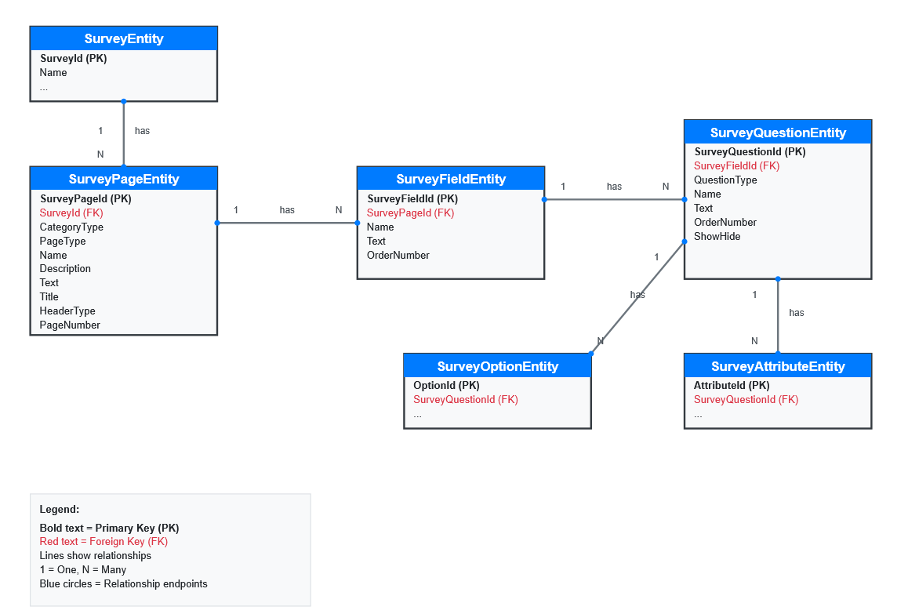
Figure 50: A diagram of the database schema, showing relationships.

Results

BC Pages and Questions
After the modified sheet was uploaded, the deleted questions were no longer shown. There was a new War Pensions Income Page which asked the radio question “Do you receive a war-related pension?” This then showed all the options for war-related pensions, which triggered further questions to get the needed detail (Figure 51). When the user reached the results page this information was then used to show them appropriate information for their situation (Figure 52).
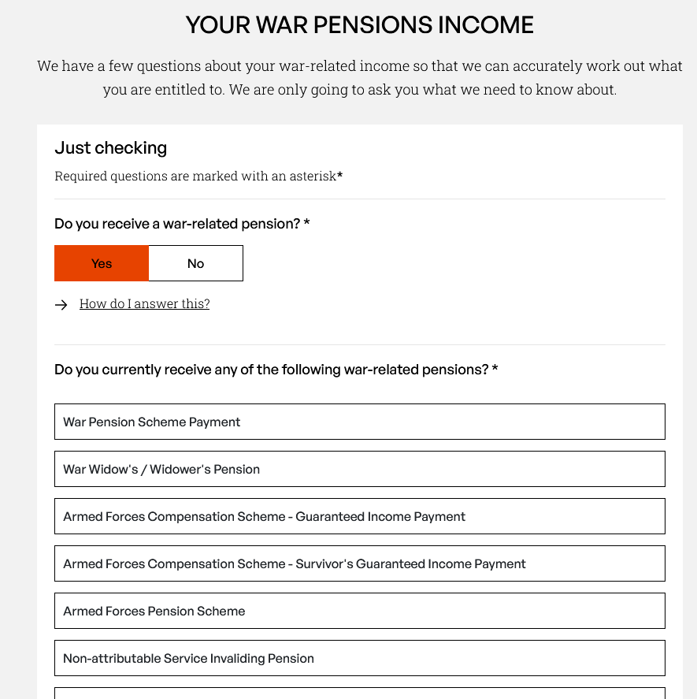
Figure 51: The new war pensions page and questions

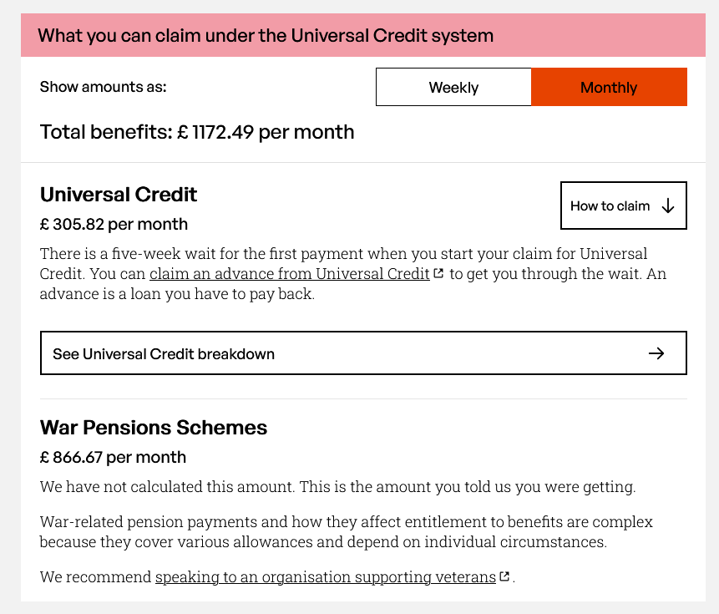
Figure 52: Results page showing the war pensions results being displayed

Benefits Specialist User Stories
Once the changes were deployed to the UAT environment, the benefits specialist tested against their user stories document to work through complicated benefit scenarios. They noted the results, and this was then double checked by another benefits specialist. These changes could then be deployed to the live tool.

Knowledge matrix
ID | Knowledge | Section
K10 | Principles and uses of relational and non-relational databases. | 5.5

PIP React testing (Testing code at Turn2Us)

Overview
At Turn2us, our testing policy primarily relies on manual testing to validate our products. As part of an initiative to explore automated testing, I introduced tests into one of our projects as a proof of concept. Specifically, I added testing to the PIP Helper frontend using Jest (unit testing) and Cypress (end to end testing) to demo testing which could increase reliability. We are aiming to modernise our deployment to have a pipeline to which we could integrate automated testing.

Stakeholders
The digital team - strategic oversight and evaluation of automated testing adoption across projects
PIP team members - collaboration on test requirements and validation of testing approach for the PIP Helper tool

Skills matrix
ID | Skills | Section
S5 | Conduct a range of test types, such as Integration, System, User Acceptance, Non-Functional, Performance and Security testing. | 6.5.2,6.5.3
S13 | Follow testing frameworks and methodologies. | 6.5.2,6.5.3

Behaviour Matrix
ID | Behaviours | Section

Planning

What to Test
I had a focus on frontend testing, as this is more visual and might make a better demo especially for non-technical stakeholders. Our frontend is made with JavaScript and React, and I had been trained on testing this in my bootcamp and had subsequent training days since. This led me to choose Jest and Cypress as my testing tools.
While testing of our C# backend was another option, I opted against it in favour of creating a more visually engaging demonstration for colleagues. When researching C# options, I found that there are two main platforms for testing VSTest and MTP (Microsoft Testing Platform). Among the available testing frameworks, xUnit.net caught my attention as it is open source, community focused and supports both VSTest and MTP.

Identifying Suitable Code to Test
I examined the code base to find some suitable components to add tests for. I decided to demo by testing components that do not have too many interactions with other components and wouldn’t need a lot of mocked data. I also thought it would be useful if I knew the code well, so I wanted to test a component I had worked on as this may allow me to create more meaningful tests.

Task Implementation

Issue with Dependencies
I encountered errors getting the frameworks to install for the project due to outdated dependencies. I had to upgrade the React icons and history dependencies to ensure compatibility with jest and cypress testing frameworks. After resolving these dependency conflicts, I was able to configure the project to execute the tests from the command line.

Jest Unit Tests
I developed Jest unit tests for three components: Accessibility, ErrorText and the FeedBack components.

Accessibility Component:
I tested the Accessibility Component, which consists of a button to show the full accessibility menu (Figure 53).
- I tested that it rendered correctly and showed the correct text.
- When it is clicked, it will trigger the function to open the menu.
- When it is rendered with the menu open, the menu is visible.
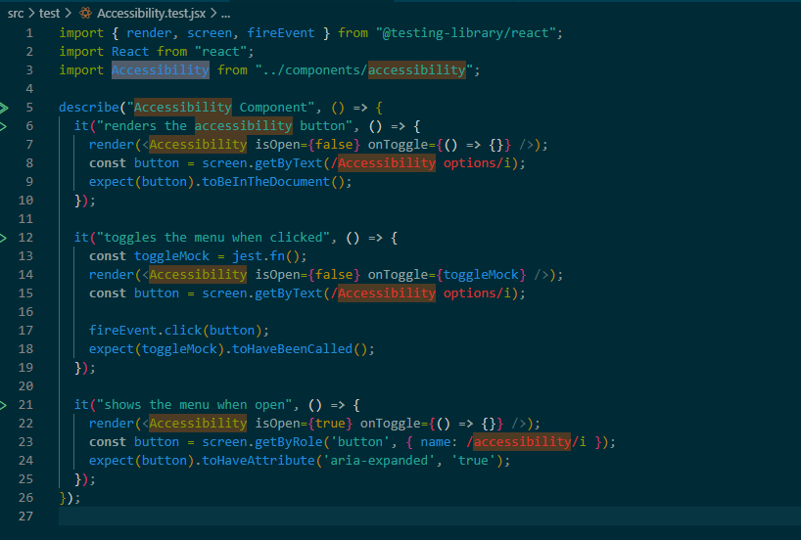
Figure 53: The tests for the accessibility component

ErrorText
For the ErrorText component, I created tests to verify its conditional rendering:
- If the invalid prop is set to true, the component should show the appropriate error message.
- If the invalid prop is false, the component should not render any error text.

Feedback Component
The Feedback component required validation to ensure behaviour: (Figure 54)
- With mock prop data for the question text, I tested whether the component displayed correctly.
- I confirmed that, upon submission, a thank-you message is presented to the user.
- I verified that if an answer has already been recorded, that the component returns null, preventing unnecessary re-rendering.

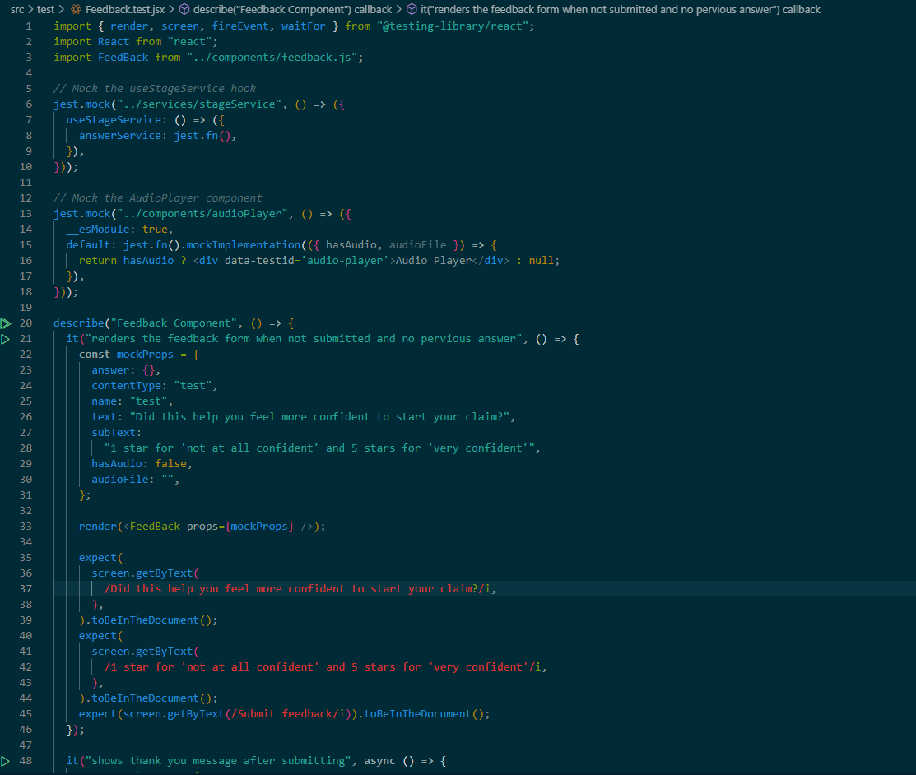
Figure 54: The tests for the feedback component

End to end tests:
I developed end to end tests using the cypress framework. I made tests for the homepage, the how to claim page and a multi-page test.
The homepage test checks that (Figure 55-56):
- The h1 renders and contains the words “Turn2us” and “PIP”.
- Checks the all the links have a href attribute to ensure they are not broken.
The How do you start your claim page (Figure 57):
- The h1 renders and contains the correct text.
- The dropdown shows specific information when Scotland is selected.
- Checks the Report a Problem Form:
  - The form reveals when the button is pressed.
  - The form loads and has all the expected fields.
  - It should be possible to pick a problem category.
  - It should be possible to fill the form in.
  - It should give an error if the required inputs are not all filled in.
The multi-page tests:
- Checks you have arrived on the main page by the h1
- Clicks on the link to the how do you start your claim page
- Checks you are on the how do you start your claim page by the h1 (Figure 58)
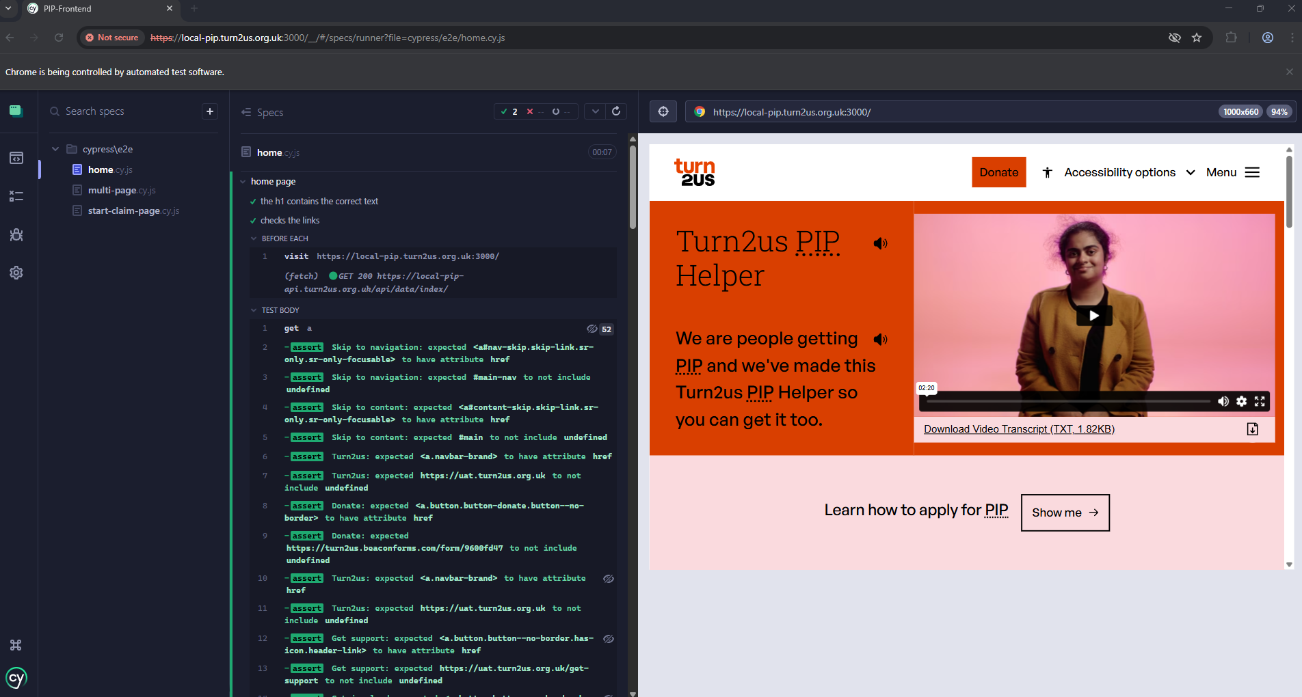
Figure 55: Home page tests: H1 and links
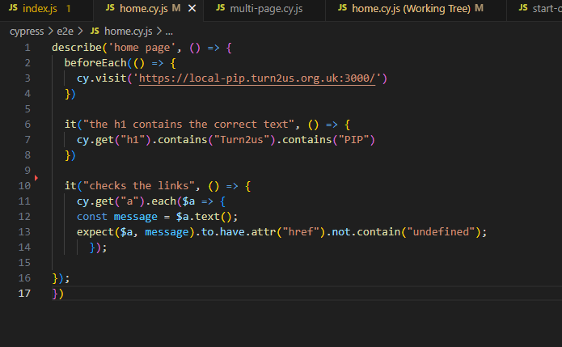
Figure 56: Cypress home tests code

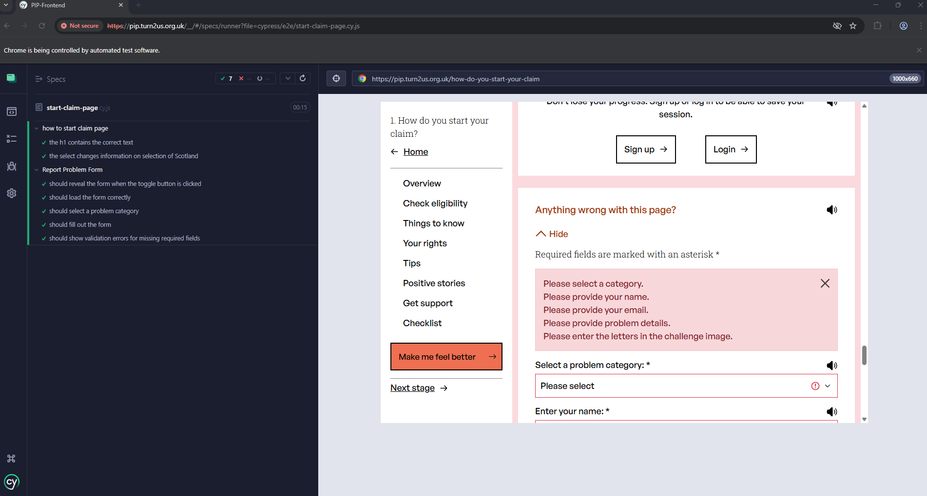
Figure 57: How to start claim page it tests H1 and report problem form

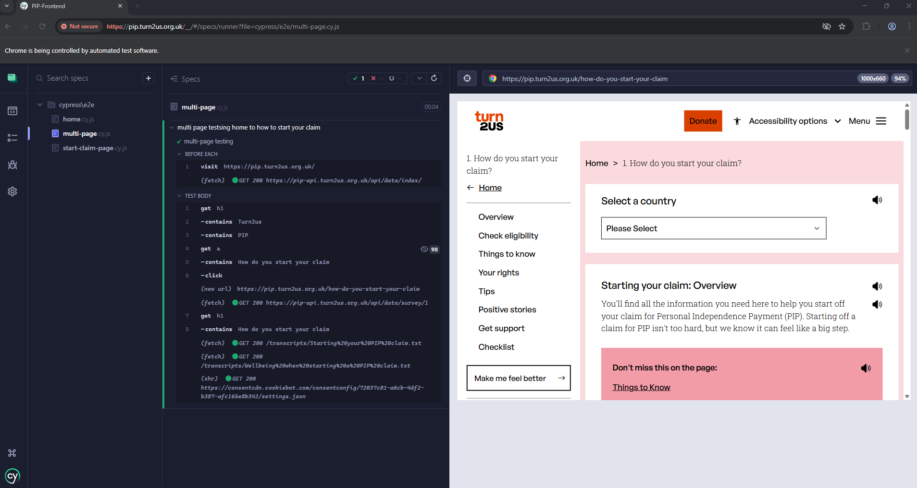
Figure 58: Multi-page testing: it checks the homepage h1, checks for the link to the how to start your claim page clicks it and checks the h1 for this page

Results

Jest tests
The jest tests provided immediate feedback on test execution and displayed test coverage for the project. The current coverage is low, indicating an opportunity for further improvement, which could be an area of focus in future development (Figure 59-60)

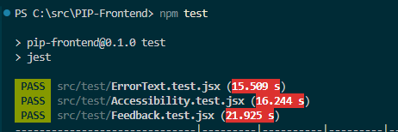
Figure 59: Running the jest tests from the command line and the results

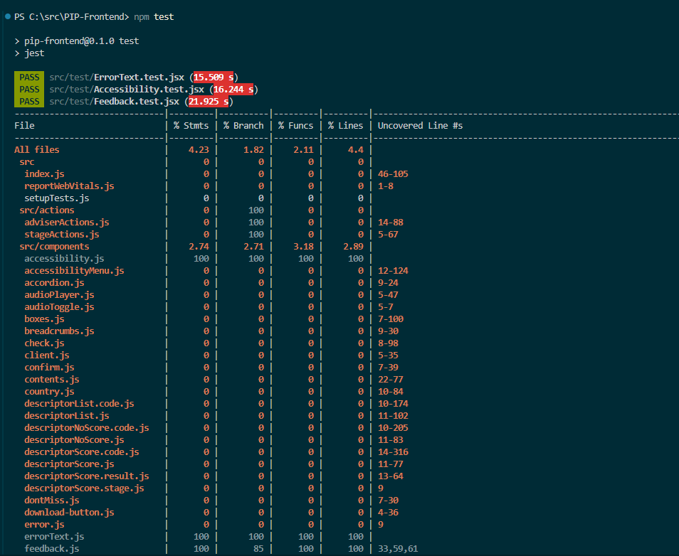
Figure 60: Jest showing the test coverage of our code base

Demo
I demoed the Jest and Cypress testing in the daily stand up, to show the PIP team how this is useful to test the tool. My colleagues thought this looked very interesting and likely to be useful in the future when we set up a continuous integration and deployment pipeline. My manager demoed this work to the head of digital so she could see in action.
  - Knowledge matrix
ID | Knowledge | Section
K12 | Software testing frameworks and methodologies. | 6.5.2,6.5.3

Portal test website

Overview
In the daily PIP stand up a colleague asked me to create a website to house an iframe portal version of our tool. The purpose was to test if the page would display correctly on a third-party website. This was part of a larger piece of work to prepare the tool to be used with our corporate partners on their websites.

Stakeholders
PIP team - daily collaboration and technical requirements for iframe integration testing
Corporate partnerships team - validation of tool functionality for deployment on partner websites

Skills matrix
ID | Skills | Section
S2 | Develop effective user interfaces. | 7.5.3

Behaviour Matrix
ID | Behaviours | Section
B6 | Shows initiative and takes responsibility for solving problems within their own remit, being resourceful when faced with a problem to solve. | 7.5.3
B8 | Shows curiosity to the business context in which the solution will be used, displaying an inquisitive approach to solving the problem. This includes the curiosity to explore new opportunities, techniques and the tenacity to improve methods and maximise the performance of the solution and creativity in their approach to solutions. | 7.6.4

Planning
I thought about where I could host this website, as it needed to be a third-party site. I decided on GitHub pages, as I had used this before and it is free to use. I made a GitHub repo and I kept the code nondescript, as it is a public repo and therefore it can be searched.
I had to choose which tech stack to make this portal website. I decided to create something lightweight and simple. I decided to use vanilla HTML, CSS and JavaScript and to add a CSS framework (bootstrap) to make this boilerplate website to host the iFrame portal. I researched some suitable bootstrap web page elements such as a header, hero section and footer.
My colleague supplied me with the documentation that he is going to supply to corporate partners to use the portal (Figure 61). I read this and planned to follow the steps to test the user journey. I noticed a typo and informed my colleague so he could correct this. (It says grant search in the notes rather than PIP Tool.)

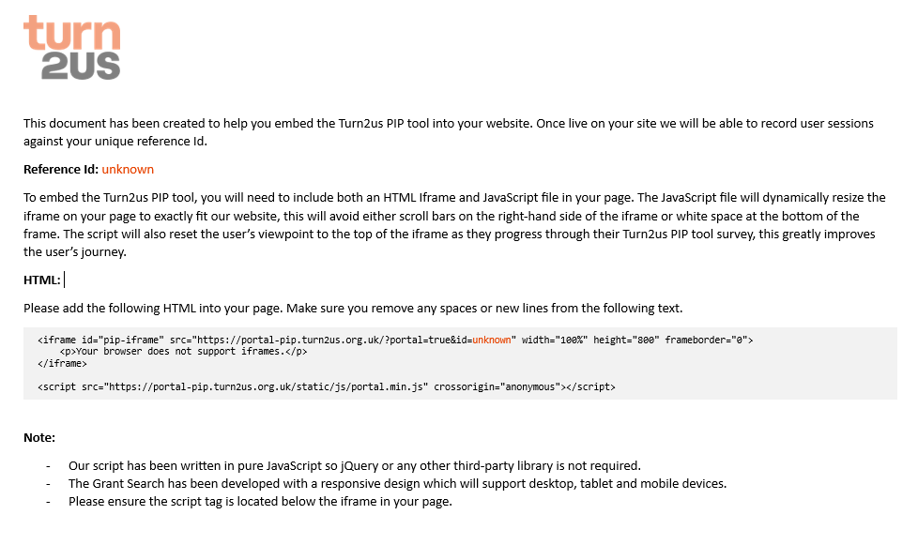
Figure 61: Corporate partners document to onboard PIP portal users

Task Implementation

Set Up
I created a GitHub repository online and cloned this to my local machine. I then built the page with basic HTML and implemented the necessary iFrame element to embed the portal. I integrated bootstrap components to enhance the page’s appearance. I added a hero section with a toggle button that allows for testing of the portal with and without the hero section.

Documentation Testing
When following the document, the portal didn’t work as expected. I noticed that there was a white space in the URL which was caused by the formatting of the document. Once I removed the space, the portal was displaying but couldn’t make a connection (Figure 62). I reported back to my colleague on Teams so he could investigate the problem. He reported that he needed our server provider to address the problem. He raised a ticket, and it was sorted in 24 hours (Figure 63).

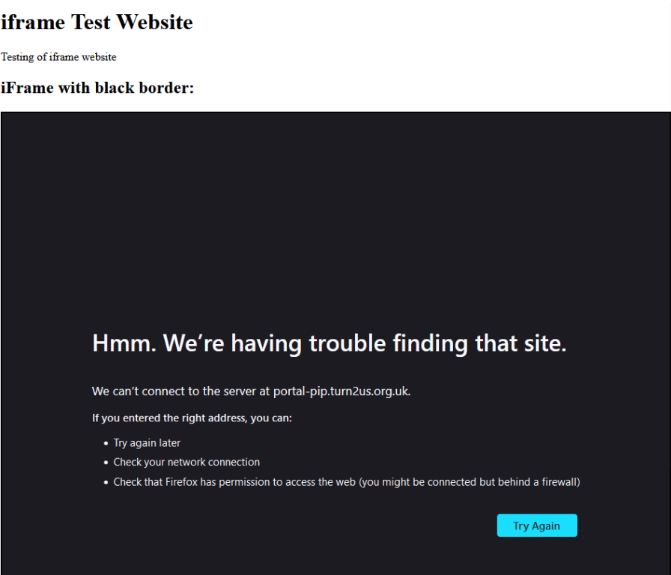
Figure 62: Portal initially not working
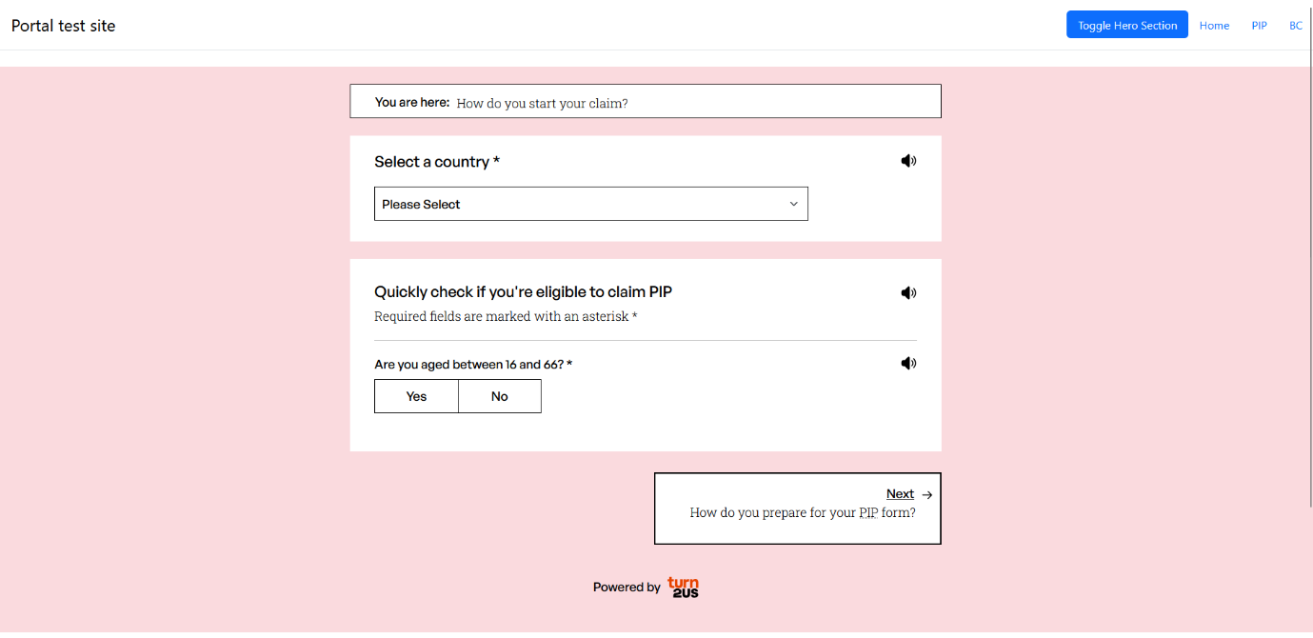
Figure 63: Portal working as expected

Portal Testing Site Potential
While working on this site I realised the potential use, to help test our other tool, the BC, in the portal version. I added a page for the BC so this portal could also be checked. When I was given another white labelling of the BC calculator to do for Local London, I was able to use the site to be able to see how my CSS changes were affecting the portal. I designed this to be able to work with portals from different environments such as local, UAT, Staging and Production to display them side by side (Figure 64).

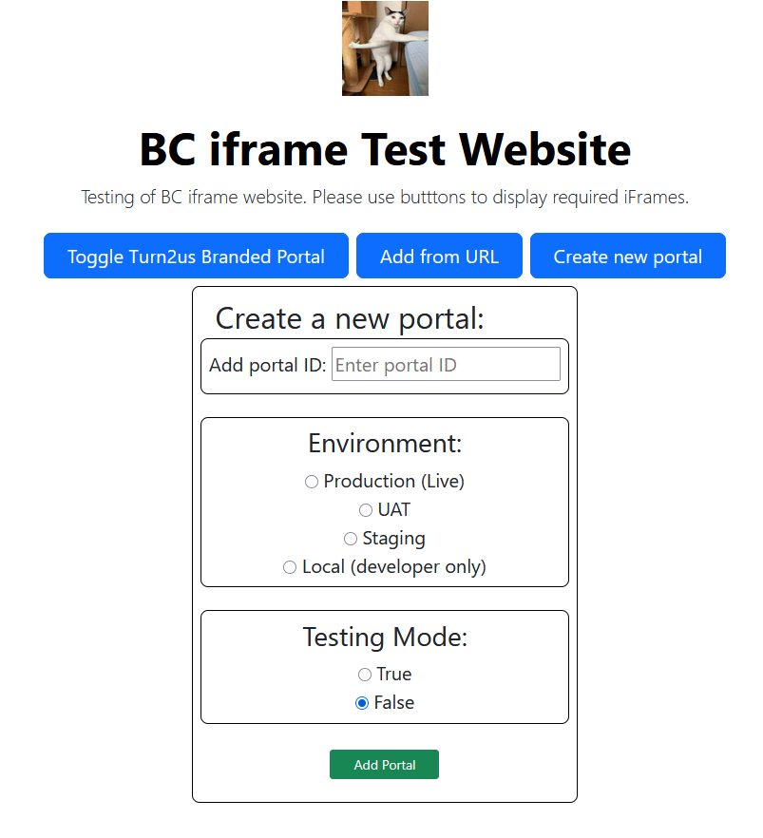
Figure 64: The initial BC page to choose a portal

Results

PIP Portal Corporate Partners Documentation
This GitHub page served the purpose, and I could test the portal set up documentation for my colleague. This allowed him to set up the required configuration with our server provider to allow portal versions of our tools to be used on third party websites. My colleague could continue with his development of the onboarding process for new partners to the PIP portal. The corporate partnerships team were relieved that the onboarding process and documentation was now ready to share.

Further Use
This website has been used since by PIP team members in further development of the PIP portal version, to check portal-specific questions and messages. For the BC it would also serve to test calculations quickly in multiple environments at once.

Incorporation to Turn2us Tools
While in a one to one with my manager I demoed the development I did, to allow for easy testing of the BC white labelled versions as I found it very useful. He was very impressed, and wants to incorporate it into the admin section of our tools for the PIP and BC. This will allow colleagues to test portal versions on an official Turn2us site.

Deployment checking
While developing the BC white labelling for Local London, the site allowed me to test as I developed locally, and I could quickly check deployments. Which was useful to check quickly if an expected deployment was in the correct environment (Figure 65).

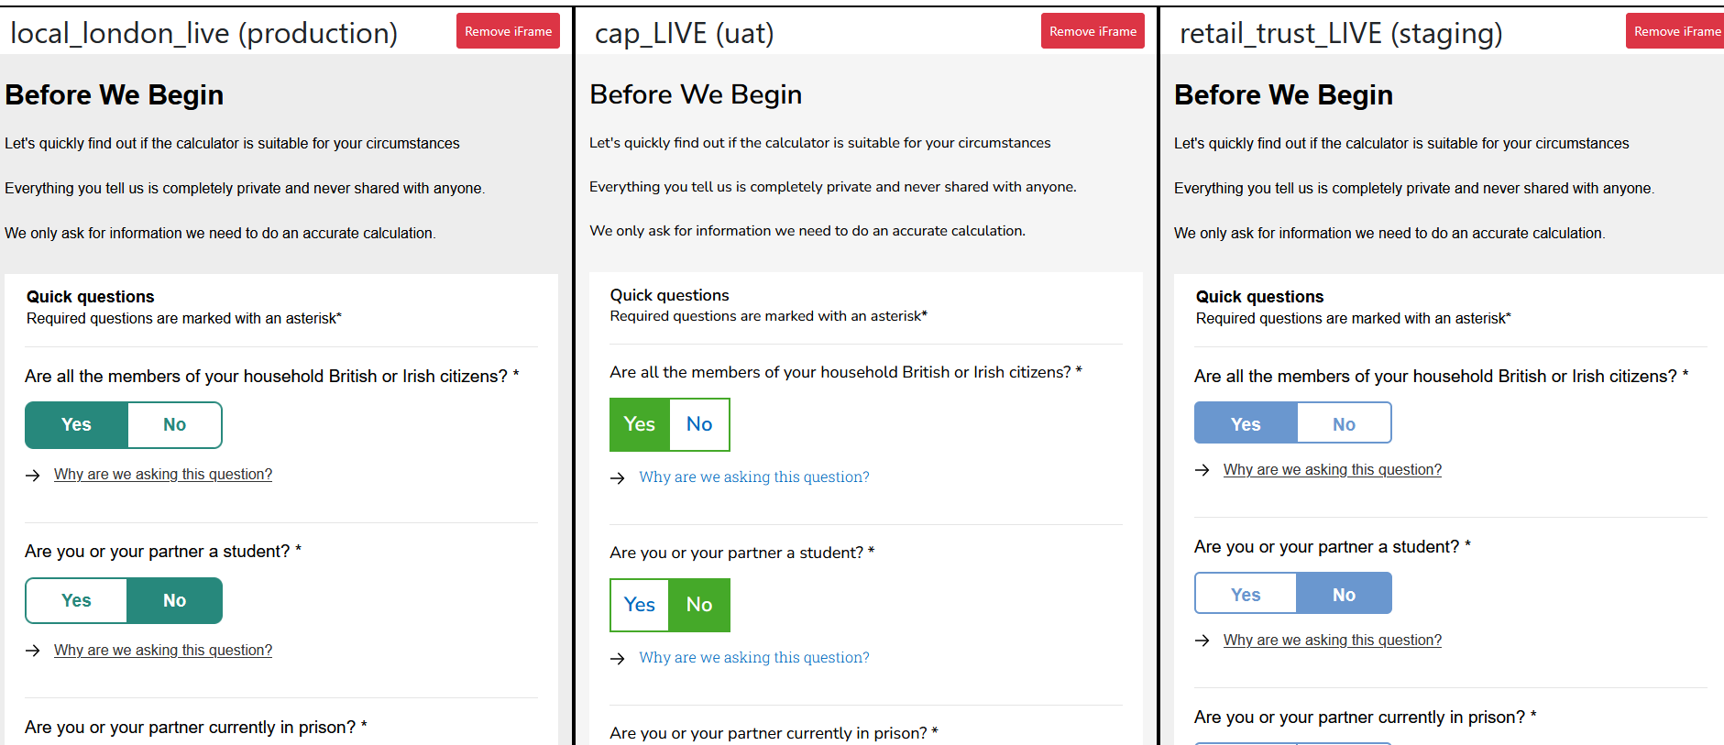
Figure 65: Note the different environments in the title of each iFrame

Knowledge matrix
ID | Knowledge | Section
K7 | Software design approaches and patterns, to identify reusable solutions to commonly occurring problems. | 7.6.2

Professional Development

  - Training
After completing my apprenticeship bootcamp, I continued to attend training days with my training provider Founders and Coders (FAC). Once I started in my workplace, I was supplied an account on Pluralsight which I can use to learn about C#. My manager recommended suitable courses for me to start with, and I used this extensively to gain experience with C#. In addition, I worked with many popular freely available resources such as freeCodeCamp, scrimba, YouTube and CS50x. Under the guidance of my developer mentor, we also came up with ideas for projects for me to build which used similar technology to the main projects as part of my onboarding as a developer.

CS50X
I enjoyed working on Harvard’s CS50x course which has a great syllabus, including how to think algorithmically and solve problems efficiently. Topics include abstraction, algorithms, data structures, encapsulation, resource management, security, software engineering, and web programming. Languages include C, Python, SQL, HTML, CSS, and JavaScript. CS50x has an interesting problem set with relatable real-world problems. I particularly enjoyed Fiftyville, a SQL challenge to solve the mystery of the stolen CS50 duck. I was able to attend an in person CS50x training day in Oxford where we worked on problem sets and met staff and students from the course.

Mentoring
As part of my apprenticeship program, I have mentored with FAC, and I have also volunteered my personal time to attend FAC meetups to help beginners start to code. I enjoyed this and it helped solidify my knowledge of basic concepts, such as using GIT and GitHub and helped me to develop my professional network.

Coding Meetups
I have been able to attend many coding meetups in the London area. They are free to attend and usually take place in the evening, so this has been accessible for me. I have attended London.js, React Girls, .Net User group, JavaScript London, QueerJS and Softwire lightning talks. These have helped me by growing my professional network, being exposed to interesting topics and to see some of London’s tech scene (events are hosted by companies typically located around silicon roundabout).
With these opportunities I have joined discord communities, meetup groups and made LinkedIn connections.

